
WARWICKSHIRE FEDERATION OF WIs
celebrates its 95th anniversary with a
FLOWER FESTIVAL

“A CELEBRATION OF
INSPIRATIONAL WOMEN”

In the historic Great Hall of the Lord Leycester Hospital, Warwick
Saturday 7th December 2013
10.00am – 4.oopm
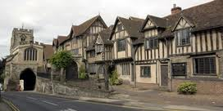

Floral exhibits by WI members representing inspirational women, past and present

Display from the archives of inspirational women from Warwickshire WIs during World War II

Tickets: £3 (children under 16 free)
Available from admin@wfwi.co.uk in advance, or on the door.
Refreshments available for purchase
Registered Charity Number: 213293 Enquiries to WFWI Office: 01926 419998 / admin@wfwi.c0.uk

