HONINGTON AND SAPISTON
WOMEN’S INSTITUTE
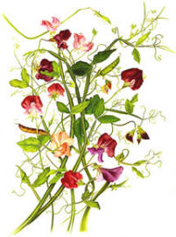
PLANT SALE
BEDDING PLANTS
SALAD & VEGETABLES
PERENNIALS
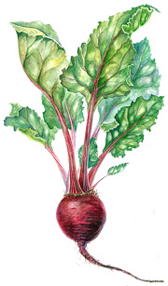
In The Village Hall
Monday (Bank Holiday)
1st MAY
10.00am – 4.00pm
Tea, Coffee & Home Made Cake
Also Art Exhibition & Sale

HONINGTON AND SAPISTON
WOMEN’S INSTITUTE
PLANT SALE
BEDDING PLANTS
SALAD & VEGETABLES
PERENNIALS

In The Village Hall
Monday (Bank Holiday)
1st MAY
10.00am – 4.00pm
Tea, Coffee & Home Made Cake
Also Art Exhibition & Sale

