SUFFOLK WEST FEDERATION OF WOMEN’S INSTITUTES
Public Affairs Committee
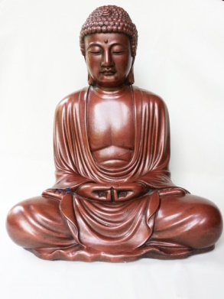
You are invited to visit the
Buddhism Vajransana Retreat Centre at
Walsham-le-Willows
Wednesday 28th June 2017at 2pm – 4.30pm
It’s not quite what you expect to encounter on the edge of the sleepy village of Walsham-le-Willows……
Escape the hustle-bustle and stresses of modern life for a short while and visit the
Vajrasana Retreat Centre, a magnificent and modern Buddist Haven, an on-site residential community of Dharmachari’s (Abhayavajra, Jnanaruchi and Saddhaketu). Do come and learn more about Triratna /Buddhism, along with visiting the gardens and the award winning retreat centre.

Address: Vajrasana Retreat Centre, Potash Farm, Walsham-le-Willows, IP32 3AR
(members own transport to this event). Map available from SWFWI office office.swfwi@gmail.com

Tickets are £5 for members and £8 for non-members. Final date to book is Wednesday, 21st June 2017
Please note: All bookings represent a commitment to pay. Please contact the office if you are unable to attend.
……………………………………………………………………………………………………………………………………………………………………………………………………. Buddhism Vajransana Retreat Centre. Wednesday 28th June 2017 at 2pm – 4.30pm £5 members £8 non-members
WI …………………………………………………………… Contact name ……..…………………………………………
Address……………….………………………………………………………………………………………………………….
Telephone……………………………………………… Email………………………………………………………………..
Name | Phone Number of each attendee – for us to contact you in case of emergency | Email address
Please Invoice our WI for …………….tickets required @ £5.00 member and £6 non-member
Please return form to:-S.W.F.W.I., Unit 11, Park Farm Business Centre, Fornham St Genevieve, Bury St Edmunds, Suffolk, IP28 6TS or email to office.swfwi@gmail.com and we will invoice your WI

