SUFFOLK WEST FEDERATION OF WOMEN’S INSTITUTES
Public Affairs Committee

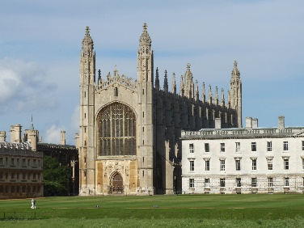
Join us for a Day Trip to the Polar Institute and King’s College, Cambridge on Tuesday 10th October 2017 10.00am start

The Public Affairs Committee has organised an exciting day out in Cambridge and would love you to join us!
The trip includes:
- A Guided Tour of the Polar Institute
- A Guided Tour of King’s College Cambridge
- Reserved seats at Evensong in the King’s College Chapel with the full choir. (This is a free extra option, starting at 5.30pm)
Numbers are restricted to 40 people for this event, so book early to avoid disappointment. The group will be halved. One half will tour the Polar Institute in the morning, and visit King’s College in the afternoon. The second half will visit King’s College in the morning, and tour the Polar Institute in the afternoon. There is then the option in the early evening to listen to Evensong in the King’s College Chapel with the full choir. (Not something which happens every day!)
No transport is provided, but the Park and Ride system closes at 9.30 pm so could be used. There is a lot of walking involved in this trip, so may not be suitable for the less agile
Tickets are £22 for members and £25 for non-members. Final date to book is Wednesday, 20th September 2017 Please note: All bookings represent a commitment to pay. Please contact the office if you are unable to attend.…………………………………………………………………………………………………………………………………………………………………………………
Polar Institute/King’s College, Cambridge Tuesday, 10th October 2017 at 10.00am start £22 members £25 non-members
WI …………………………………………………………… Contact name ……..…………………………………………
Address……………….………………………………………………………………………………………………………….
Telephone……………………………………………… Email………………………………………………………………..
Name | Phone Number of each attendee – for us to contact you in case of emergency. Pref. mobile | Email address | Will you be attending evensong?  Yes? No?
Please Invoice our WI for …………….tickets required @ £22.00 member and…. £25 non-member
Please return form to:-S.W.F.W.I., Unit 11, Park Farm Business Centre, Fornham St Genevieve, Bury St Edmunds, Suffolk, IP28 6TS or email to office.swfwi@gmail.com and we will invoice your WI

