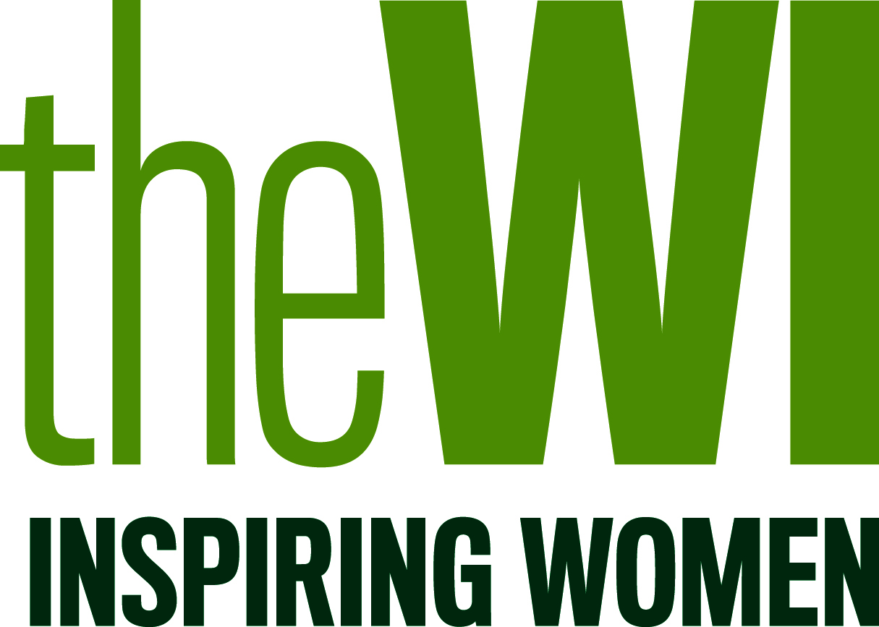
NFWI
Resolution submission form

Please ensure that you have read the resolutions guidance note before completing your submission form. You can download this at https://www.thewi.org.uk/campaigns/resolutions-and-mandates or contact the NFWI public affairs team.

This form can also be completed online at: www.thewi.org.uk/campaigns/resolutions-form

The completed form must reach the Public Affairs Department at the NFWI by 14th September 2018. Resolutions received after this deadline will NOT be accepted. Submission forms can be sent by email to pa@nfwi.org.uk or posted to NFWI, 104 New Kings Road, London, SW6 4LY.

Details of WI or federation submitting this resolution
WI:_________________________________________________________________________
Federation: ___________________________________________________________________
This resolution was agreed at a meeting held on (date):______________________________________
Contact name and position:_________________________________________________________
Contact details: Email_____________________________________________________________
Phone Number_________________ Postal Address______________________________________ ____________________________________________________________________________ Name of proposer who will speak at the Annual Meeting: ____________________________________

Title of resolution: ______________________________________________________________________________________________________________________________________________________________________________________________________
Wording of resolution: ____________________________________________________________________________________________________________________________________________________________________________________________________________________________________________________________________________________________________________________________________________________________________________________________________________

NB. The NFWI may amend the title and/or wording to make it clearer and/or easier to achieve. The NFWI will consult the proposing WI about any proposed amendments.

The Federation Resolutions Adviser (FRA) or Federation Representative (Federation Chairman or Treasurer)
has seen the above resolution and the format approved. (Signature of FRA or other Federation representative)

Name: ________Position:___________________________
Signed: Date: _____________________
Please ensure you get in touch with your federation as soon as possible as federations will have their own deadlines by which they can approve resolution submissions.

THE ISSUE
What is the problem addressed by your resolution? Who is affected and how are they affected?
- Is it topical and timely? Does it fit with current areas of public interest?
- Is it appropriate? Does it fit with the WI’s charitable objects, our history and ethos?

OBJECTIVES
- If the resolution is successful, what do you hope a campaign will achieve?
- Is it targeted and achievable? Does the resolution have a clear and realistic objective?

POTENTIAL
- Does your resolution have partnership potential? How can the NFWI’s work add value to the work of other organisations?
- Will the WI gain positive media coverage from campaigning on this issue?

Please use additional sheet(s) if necessary

