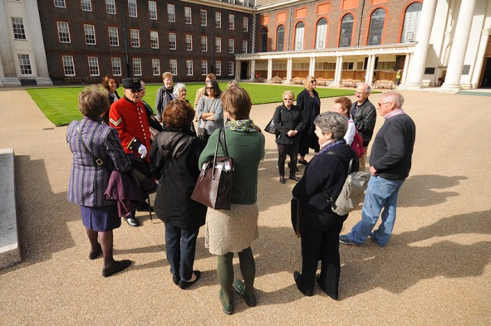
SUFFOLK WEST FEDERATION OF WOMEN’S INSTITUTES
LEISURE SUB COMMITTEE
A COACH TRIP TO THE ROYAL HOSPITAL CHELSEA
including a guided tour by one of the resident Chelsea Pensioners.
Tuesday 26 September 2017
Please note change of date from original advertising this is due to the fact that tours during the afternoon are only on certain days and this is the nearest available
COST £40.00 PER MEMBER AND £42.00 PER NON MEMBER
Leaving Bury St Edmunds Bus Station at 8.00 am and with a pick up in Newmarket at approximately 8.30 am.(approximate time of arrival in Chelsea 11 am leaving at approximately 4pm.)
Join the Leisure Committee for a fabulous day out in London, we hope to arrive in London mid morning around 11/11.30 depending on traffic. You will then be free for a couple of hours for coffee and lunch etc. There are many interesting places in the area, The Physic Garden, The Saachi Gallery, Chelsea and The Thames are also very near.
There is also the chance to have a light lunch in the Margaret Thatcher Infirmary café in the grounds from 12 noon; if you wish to have lunch there please tick the box as we need to know numbers in advance so that the Café can cater. We will meet again at 1.15pm for our tour at 1.30pm, the tour takes between 90 minutes and 2 hours and the guides are real characters and so entertaining.
Please come and join us on this day out!!!! Closing date for applications 27 July 2017. Thank you.
Royal Hospital Chelsea 26th September 2017. £40 per member and £42 per non-member
WI……………………………………Contact Name…………………………………………..
Address ……………………………………………………………………………………….…

………………………………………………… Tel No………………………………………

NAME | Telephone number in case we need to call you on the day – pref. mobile | Do you want to buy a lunch at the Café? | Member/Non-member

Please Invoice our WI for …………….tickets required @ £40 per member and …….£42 per non-member. Please return form to:-S.W.F.W.I., Unit 11, Park Farm Business Centre, Fornham St Genevieve, Bury St Edmunds, Suffolk, IP28 6TS or email to office.swfwi@gmail.com and we will invoice your WI

