NFWI MEMBERSHIP DEVELOPMENT COMMITTEE
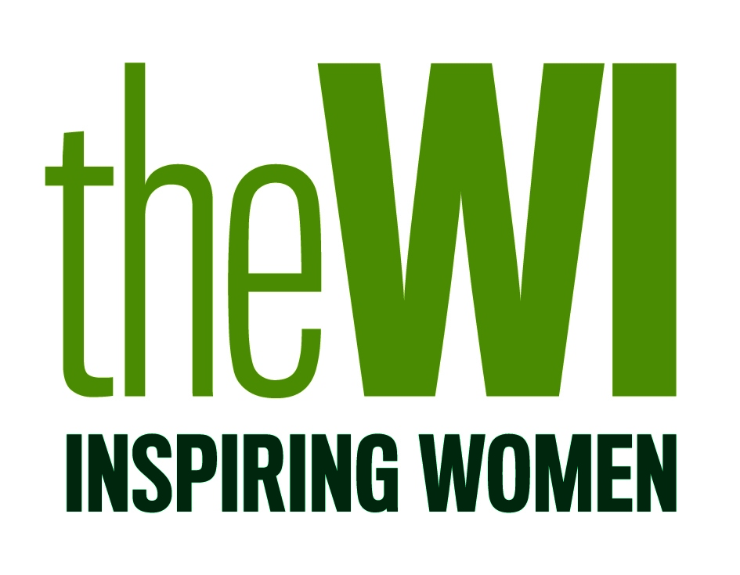
LISTEN-SPEAK-INSPIRE WORKSHOPS
A CONFIDENCE BOOST

Application Form

Date | Venue | I will attend  (please tick) | Closing  Date for  Application
9 March 2019 | Warwickshire Federation  Federation House  1 Corunna Court  Corunna Road  Warwick  CV34 5HQ |  | 28 February 2019
27 April 2019 | Durham County Federation  WI House  Barnfield Road  Spennymoor  Co Durham DL16 6EB |  | 19 April 2019
22 June 2019 | Berkshire Federation  WI House  The Street  Mortimer Common  Reading  RG7 3RD |  | 15 June 2019
19 July 2019 | Clwyd-Flint Federation  Venue to be confirmed |  | 10 July 2019

The cost of attending is £20.00. Please indicate which venue and date you wish to attend and return your completed form to Elaine Smith, Accreditation Officer, NFWI Unit, Denman, Marcham, Abingdon, Oxon, OX13 6NW along with your payment. Cheques should be made payable to NFWI.

Name:

Address:

Telephone Number: |  | Email:

