COUNTRY: Cameroon
SOCIETY: Cameroon Gender and Environment Watch (CAMGEW)
PROJECT: Improving the livelihoods of indigenous Mbororo women around Kilum-ljim forest
PROJECT NO: 1031
SWFWI COMMITMENT: £3947. ACWW will allocate the £342.62 which has been received recently from SWFWI to this project.
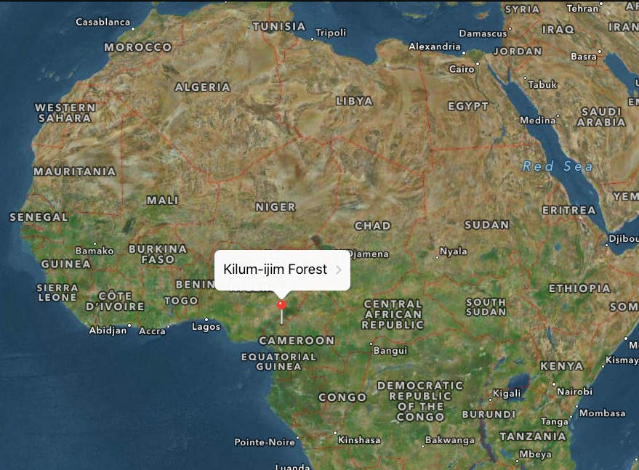

This project seeks to empower Mbororo women in Mboclenghas village, Kilum-ljim forest in North West Cameroon. It will involve activities for income generation, improvement of nutritional standards and training in agroforestry and vegetable gardening. They will also teach the women how to sell cow dung to other farmers as an additional source of income. The project will continue for 12 months and is expected to reach more than 800 women and children from the indigenous community.
The Mbororo are an indigenous Muslim community within which almost 90% of households are polygamous and most of their girls marry at an early age. Poverty and poor nutrition are widely present amongst these women. As they mostly stay at home, they are not exposed to income generating activities. After completing a field study, CAMGEW concludes that Mbororo women lack knowledge on healthy nutrition and a balanced diet. Their children have general body weakness and often suffer from malnutrition, anaemia, and gastrointestinal tract infections as a consequence of a poor diet. Therefore, the project is crucial for it will train these women to produce their own food and reduce dependency on other communities.
CAMGEW will carry out two practical training workshops on improved nutrition and a balanced diet. The women will be encouraged to gather cow dung into bags and retail to other farmers as a means of income generation. Due to their culture of cattle rearing the Mbororo have vast lands and cow dung in abundance, but they tend to engage less in agriculture. Chemical fertiliser is very expensive and peasant farmers are rarely able to afford it. This is an advantage to Mbororo women and they will be trained to exploit it through the project.

Because of their access to cow dung, water and land, agroforestry training will be offered – skill training on soil conservation, and the planting of various types of trees. This will enable them to cultivate food crops, especially vegetables and fruits that can improve considerably both their capacity as income providers and the nutritional value of their produce. Organic vegetable gardening will also be introduced in the course of the project.

Please ensure, when sending in any donations for the project, that a mention of the project number (1031) is made on their covering letter or note (or at least ‘the Suffolk West project’ or some such). The cheque(s) itself should simply be made out to ACWW with the project number on the back of the cheque but please, not on the front!
ACWW are interested to receive any reports and/or photos of your fundraising activities in support of ACWW, which might be used in The Countrywoman magazine or on the ACWW website.

