
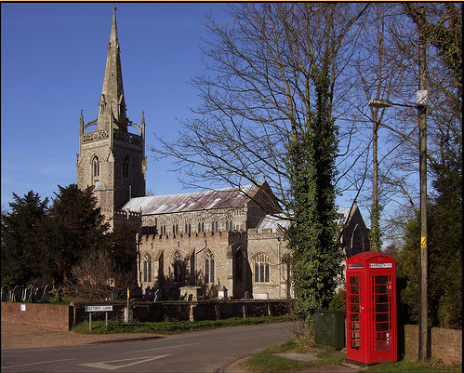
CORONATION CUP DAY EVENT

Woolpit Wander Friday14th July
Come and join us for a guided wander around the village of Woolpit. This will also include a visit to the Woolpit Museum and the historic Church of St. Mary. At both venues you will enjoy a guided tour. There are a maximum of 15 spaces for each walk time.
Meet at Woolpit Institute near the Market Cross for either the 2-30 to 3-30pm or the 4 to 5pm start.
Please book through the office - £5 per person stating clearly the time you prefer when booking. This is open to both Members and non-Members so why not bring a friend?
…………………………………………………………………………………………………………………Please tear off and return
A Walk around Woolpit – Friday 14th July 2017 £5 per person

WI …………………………………………………………Contact name ……..…………………………
Address……………….………………………………………………………………………………………..
………………………………………………………………………………………………………………….
Telephone…………………………………… Email…………………………………………………………
Please give full names and contact details for all those wishing to attend
Name | Phone number in case we need to call you on the day – pref. mobile | Member/Non Member | 2.30pm or 4pm start

Please Invoice our WI …………… @ £5 per person

Please return:- S.W.F.W.I., Unit 11, Park Farm Business Centre, Fornham St Genevieve, Bury St Edmunds, Suffolk, IP28 6TS

