Events details the Baton will enjoy during its stay in Herefordshire
Day 1 : Tuesday 2nd September 2014

HFWI collects the Baton from Gwent Federation at the Park Hotel, Pandy
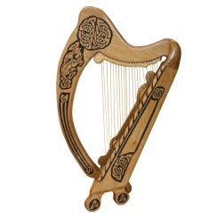
Event One.
Trustees will deliver the Baton to the Satellite Group at Moccas Village Hall – 7.30
An evening of entertainment by 15 year old harpist Martha Powell
£3.00 on the door
Please contact Julia Whittall 01981 500258

Day 2 : Wednesday 3rd September 2014
Event Two.
Weobley Group – 11am – 1pm
Val Lewis, a trustee will bring the Baton from Moccas in a decorated Triumph Herald to the Toll Bridge at Winforton, where there will be a bring and share lunch with WI memorabilia.
Please contact Val Lewis: Telephone 01544 327700.

Lady Darnley and Kathryn Bandfield, Federation Chairman will collect the Baton from The Weobley Group and take it in the Triumph Herald to The Marches Group

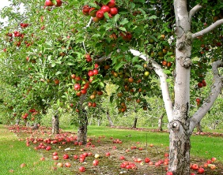
Event Three
Marches Group – 2.30pm
A reporter from the Hereford Times will be here at 2.30.
Marches Group receives Baton from Weobley Group at Staunton on Arrow Village Hall, where there will be a bring and share tea and a walk around local orchards.
Please Contact Alison Lord: Telephone 01544 340256 by 31st August 2014.

Day 3 : Thursday 4th September 2014
The Marches Group will take the Baton in a decorated tractor to The Kingsland Group.
Event four
Kingsland Group – 10.30 - 12
Kingsland Group will receive the Baton from the Marches Group at the Millennium Green where there will be a coffee morning with WI banners on display. Transport will be via Bentley
Contact Mavis Tantrum: Telephone 01544 387972

Event Five
Kimbolton Group – 2pm
Kimbolton Group will receive the Baton from June Stephens, a trustee at The Village Hall, Orelton, where there will be a Hatters tea party. Everyone should wear a decorated hat which will be judged for a small prize. There will be a bring and share tea and raffle.
Please contact Mary Springle: Telephone 01568 613347

Day 4 : Friday 5th September 2014
Event six
Ross Group - 11am and 1pm
Ross Group will receive the Baton from a Janice Durkin, a trustee and it will be transported on the River Wye. There will be a picnic in Edwardian dress at the Bandstand at 1pm.
Please contact Jenny Holmes: Telephone 01989 763575
Event Seven
Fownhope
Fownhope will receive the Baton from Cicely Symonds, a trustee at Hampton Bishop Village Hall at 2.00pm. There will be three walks of different distances around the Wye, ending at the Village Hall at 3.30pm for tea and cake.
Please contact Kay Spencer: Telephone 01432 870586

Day 4 : Saturday 6th September 2014
Event Eight
Golden Valley
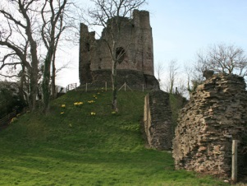
Golden Valley receives the Baton from Kathryn Bandfield, Federation Chairman at 10.00am at Dorstone Village Hall for coffee and refreshments, then to Arthur’s stone for photographs, and on to Longtown Village Hall for lunch, then Longtown Castle for photographs. The Baton will then be taken across country on horseback to Pontrilas, at Castle Lands for afternoon tea and more photographs.
Please contact Carol Powell: Telephone 01873 860550 or 07887 427196.

Day 5 : Sunday 7th September 2014
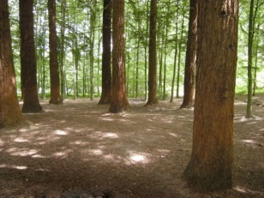
Event Nine
Holmer
Holmer will receive the Baton from June Stephens, a trustee at Queenswood at 10.00am for a bring and share breakfast. The Baton will then walk around the wood with WI banners. Wellington Village hall has been booked as a wet weather contingency plan.
Please contact Pat Simpkin: Telephone 01432 820648
Event Ten
The Baton will enjoy Afternoon Tea at lower Hope Gardens, Ullingswick

Day 6 : Monday 8th September 2014
Event Eleven
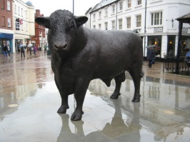
Hereford City Group
Hereford City Group will receive the Baton dressed in Edwardian costume on The Old Bridge, 10.15am. It will be decorated and transported by Pedi cab over the bridge to Victoria Bridge and through to High Town for 12.00pm, where there will be memorabilia, sale of cakes and a raffle. Tupsley choir will sing as the Baton is passed over to Bromyard at 12.15pm.
Please contact Brenda Drake: Telephone 01432 356653
Event Twelve
Bromyard Group
Kathryn Bandfield, Federation Chairman will collect the Baton from the Hereford Bull at 12.15pm and take it in a vintage Bentley to Wye Valley Brewery, where it will be passed to Much Cowarne WI and taken by horse and carriage to the Conquest Theatre in Bromyard to the rest of the Bromyard Group. The Mayor and Mayoress will receive the Baton announced by the Town Cryer. Tea and scones will be served.
Please contact Kathryn Bandfield: Telephone 01432 820385

Day 7 : Tuesday 9th September 2014
Event Thirteen
Ledbury Group – 12 -2pm
Ledbury Group will receive the Baton from Bromyard group at a picnic at Cradley Village Hall. The Baton will be transported in a Morgan to Homme House by The Federation Chairman.
Contact Rosemary Bayles: Telephone 01531 640895

HFWI passes the Baton to Worcester Federation at Homme House where the choir will sing and canapés and wine will be served.

