RETURNERS WATERCOLOURS WITH GAIL
Tuesday 25th June 2024 – 9.30am to 3.30pm at Alma House

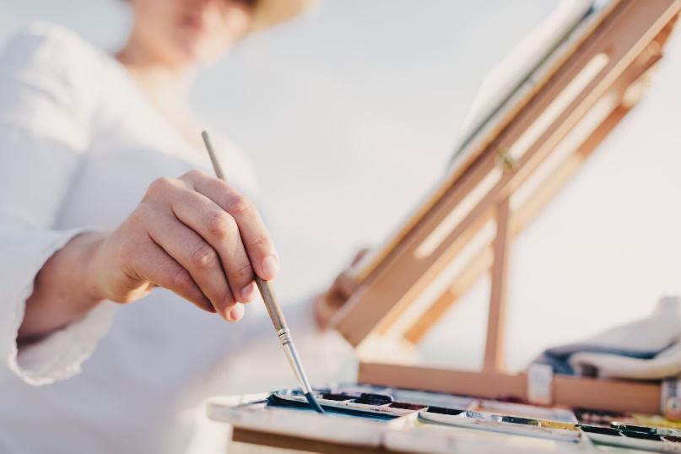
Enjoy the magic of watercolour.
Find your hidden talents and join us for an exciting time “playing with paint”. Caution – it can add an extra dimension to your life!
All materials supplied.
Maximum 12 people
Cost of workshop - £12.00 –
Cost of materials £5.00
Please bring a packed lunch!
Please note, there is no parking at Alma House.

Start Date:1st April – Closing Date: 14th June 2024
Confirmation will be issued by email after closing date
If the closing date has passed and you decide you want a place, please contact the Office for availability – 01765 606339

From WI
The following members would like to book places on the Returners Watercolours Workshop on Tuesday 25th June.

Name of member attending | telephone number | email

Payment Options
CHEQUE payable for the full AMOUNT to NYWFWI and send to North Yorkshire West Federation of WIs, Alma House, Low St Agnesgate, Ripon, HG4 1NG. Please list the event on the reverse of the cheque.
ONLINE-BACS Acc Name: NYW Fed of Womens Institute No 1 A/C Charity No 1204475 Sort code: 05-07-17 Account Number 35739439 with Reference Name/WI and sending a confirmatory email with completed form to NYWFWI24@gmail.com. Please quote code 24A08WR. Payment must be made with your booking.

Contact Name:
Email :
Telephone Number: |  | Mobile:
Signed
BOOKINGS are non-refundable. | If the event is Cancelled cheques will be destroyed - please tick if you require your cheque returned.
Confirmation will be emailed out to the contact’s name. Please note photographs taken at the event may be used on social media.

DISCLAIMER: Participants take part in ALL Federation events and activities at their own risk.

