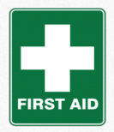
Basic First Aid Course by First Aid Skills
UK – Trainer Gloria Cooke

At Alma House
Wednesday 15th May and
Thursday 16th May 2024
Coffee at 9.00 am, to 4.00 pm
Cost £60, but we are subsidising this amount to £30 for 1 member per Institute
Places are limited. Please bring your own packed lunch
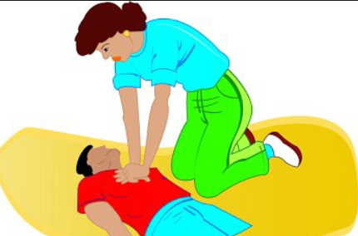

This is a basic First Aid Course with the Awarding Body Qualsafe Awards, includes a First Aid Book. Please note that members would be expected to be able to kneel on the floor to perform CPR.

Please note that there is no parking at Alma House.

Booking Start Date: 1st March – Closing Date: 26th April 2024
Confirmation will be issued by email after the closing date
If the closing date has passed, please contact the Office for availability – 01765 606339

From: WI
Please state your first and second choice on the table below:
Name and telephone number of member attending | Email Address | 15th May | 16th May

Payment Options
CHEQUE payable for the full AMOUNT to NYWFWI and send to North Yorkshire West Federation of WIs, Alma House, Low St Agnesgate, Ripon, HG4 1NG. Please list the event on the reverse of the cheque.
ONLINE-BACS Acc Name: NYW Fed of Womens Institute No 1 A/C Charity No 513934 Sort code: 05-07-17 Account Number 35739439 with Reference Name/WI and sending a confirmatory email with completed form to NYWFWI24@gmail.com. Please quote code 24A06FA

Contact Name: Email: Telephone:
Signed
BOOKINGS are non-refundable. | If the event is Cancelled cheques will be destroyed - please tick if you require your cheque returned.
Confirmation will be emailed out to the contact’s name. Please note photographs taken at the event may be used on social media.

DISCLAIMER: Participants take part in ALL Federation events and activities at their own risk

