Cream Tea at Alma House
Thursday 30th June 2022

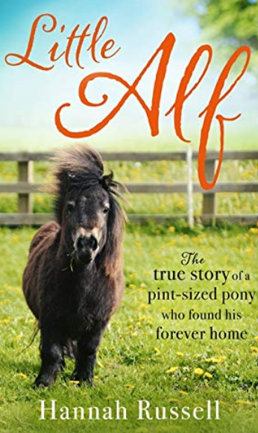

You are invited to meet up with friends for a chat over a cup of tea and scones and to hear Hannah Russell, the young and charismatic author of books about her dwarf Shetland pony, Little Alf.
Hannah also is passionate about animals welfare in general.

2.00 – 4.00pm
£15.00

Start Date: 1st April 2022 – Closing Date: 6th June 2022
Confirmation will be issued by email on 14th June 2022.
If the closing date has passed and you decide you want a place, please contact the Office for availability – 01765 606339

There will be no car parking at Alma House

From WI
The following members would like to book places for The Afternoon Tea on Thursday 30th June 2022. Please inform us of any dietary requirements. (please write on reverse of form).

Name of member attending | telephone number | email

Either please make ONE cheque payable for the full AMOUNT to NYWFWI and send to North Yorkshire West Federation of WIs, Alma House, Low St Agnesgate, Ripon, HG4 1NG. Please list the event on the reverse of the cheque.
Or alternatively pay by BACS as an on-line payment using: Sort Code: 05-07- 17 Account No: 35739439 and sending a confirmatory email with completed form to nywfwi@btconnect.com

Contact Name and address …………………………………………………………………………………………………………….
Telephone Number: Mobile:
Signed
BOOKINGS are non–refundable.
Confirmation will be emailed out. Please note photographs taken at the event may be used on Social Media.
DISCLAIMER: Participants take part in ALL Federation events and activities at their own risk.

Office Use Only: Cheque Number

