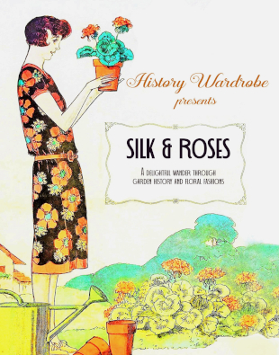
GARGRAVE VILLAGE HALL
THURSDAY 21ST JULY 2022 at 2.00-4.00 PM
Includes Afternoon Tea –
Lucy Adlington presents Silk & Roses
Just for fun – a prize for the best flowery outfit!
Price £20

Please let us know of any dietary requirements you may have.
Booking Start Date: 1ST May 2022 – 20th June 2022
Confirmation will be issued by email on 30th June 2022
If the closing date has passed, please contact the Office for availability – 01765 606339

WI………………………………………………………………………………………………………………………

Name of Member Attending | Email Address and Telephone Number

Either please make ONE cheque payable for the full AMOUNT to NYWFWI and send to North Yorkshire West Federation of WIs, Alma House, Low St Agnesgate, Ripon, HG4 1NG and please list the event on the reverse of the cheque. Or pay by BACS as an online payment using Sort code 05-07-17 Account Number: 35739439 with Name/WI Reference and sending a confirmatory email with completed form to nywfwi@btconnect.com
Contact Name, Address, and Email details………………………………………………………………………….
Telephone Number: Mobile:
Signed

BOOKINGS are non-refundable.
Confirmation will be emailed out to the contact’s name. Please note photographs taken at the event may be used on social media.

DISCLAIMER: Participants take part in ALL Federation events and activities at their own risk.

