AN INTRODUCTION TO JAPANESE GARDENING

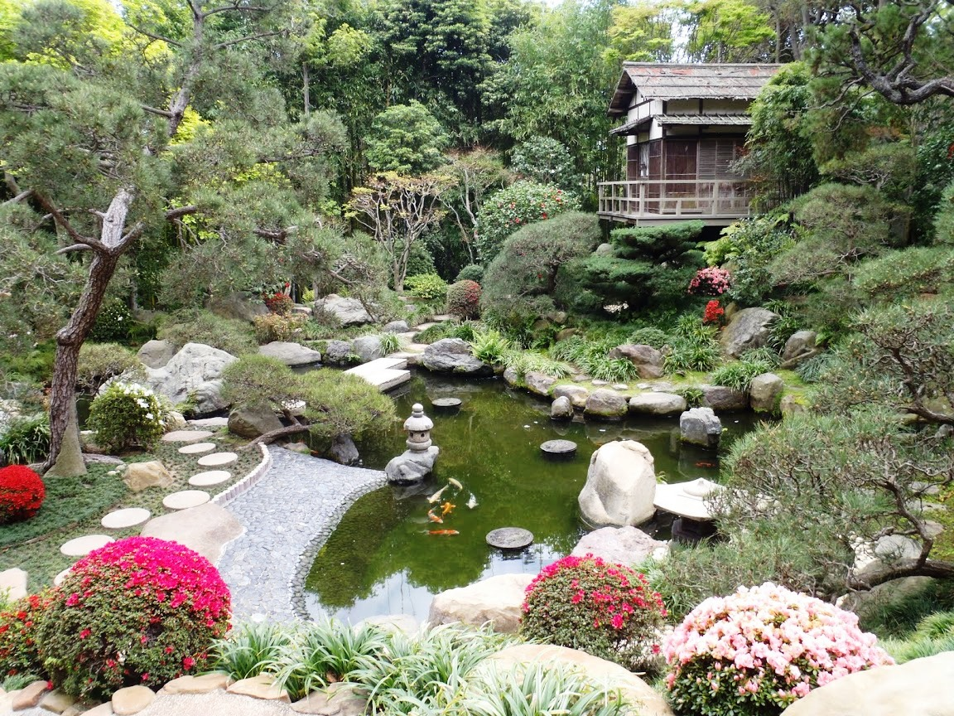

If this inspires you to recreate something similar, you will enjoy listening to Dr Andy Bolton who is a keen gardener with an interest in Japanese gardens. He has designed his own Japanese garden at his home in Tockwith. His talk will cover a brief history of Japanese gardens, types and designs features and horticultural information. Dr Bolton is the Chairman of the regional group of the Japanese Garden Society.

Join us at Bishop Monkton Village Hall HG3 3QG on Friday 20th May from 2.00pm until 4.00 pm.

Cost £17.50 – this includes Afternoon Tea.

Please let us know of any dietary requirements you may have.

Booking Start Date: 1st April 2022 – 22nd April 2022
Confirmation will be issued by email on Friday 29th April 2022
If the closing date has passed, please contact the Office for availability – 01765 606339

From: WI
Name of Member Attending | Email Address and Telephone Number
Name of Member Attending | Email Address and Telephone Number

Either please make ONE cheque payable for the full AMOUNT to NYWFWI and send to North Yorkshire West Federation of WIs, Alma House, Low St Agnesgate, Ripon, HG4 1NG. Please list the event on the reverse of the cheque. Or, alternatively, pay by BACS as an online payment using Sort code 05-07-17 Account Number: 35739439 with Name/WI Reference and sending a confirmatory email with completed form to nywfwi@btconnect.com
Contact Name, Address, and Email details:

Telephone Number: Mobile:
Signed

BOOKINGS are non-refundable.
Confirmation will be emailed out to the contact’s name. Please note photographs taken at the event may be used on social media.

DISCLAIMER: Participants take part in ALL Federation events and activities at their own risk.

Office Use Only: Cheque Number:
Date Received: Cash:

