Shibden Hall

Thursday 12th May 2022

£25.00
(Luxury Travel, Usual Pick Up Points)

Members to pay own admission at the door.

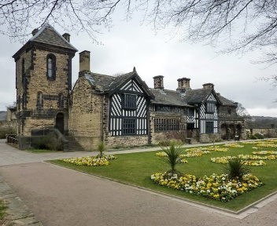

We are heading to Shibden Hall which is the birthday of Anne Lister and also a house that was used in the TV production of Gentleman Jack. We then travel to Piece Hall in Halifax where you will have free time to wander round the magnificent buildings.

Start Date: 1st Feb 2022 – Closing Date: 18th April 2022
Confirmation will be issued by email on 25th April.
If the closing date has passed and you decide you want a place please contact the Office for availability – 01765 606339

From WI
The following members would like to book places on the Shibden Hall on Thur 12th 2022. Please indicate your preference for your pick up point. Pick up points will be: Ingleton, Settle, Skipton, Ripley or Bainbridge, Leyburn, Bedale, Ripon
May
Name, email and telephone number of member attending | Pick Up Point

Please make ONE cheque payable for the full AMOUNT to NYWFWI and send to North Yorkshire West Federation of WIs, Alma House, Low St Agnesgate, Ripon, HG4 1NG. Please list the event on the reverse of the cheque.
Alternatively pay by BACS as an on-line payment using : Sort Code : 05-07- 17 Account No: 35739439 with name/WI reference and sending a confirmatory email to nywfwi@btconnect.com

Contact Name and address:

Telephone Number: Mobile:
Signed
BOOKINGS are non–refundable.

Confirmation will be emailed out. Please note photographs taken at the event may be used on Social Media.

DISCLAIMER: Participants take part in ALL Federation events and activities at their own risk.

Office Use Only: Cheque Number:

Date Received: Cash:

