Are you a confident driver?
The WI and IAM RoadSmart working together to develop women’s driving skills
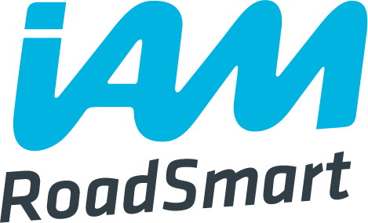
IAM RoadSmart (formerly known as the Institute of Advanced Motorists) is the UK’s leading independent road safety charity who passionately believes that our roads can be made a safer place by improving the standards of the people who are using them. With over 50 years of experience, passion and insight, the IAM is uniquely positioned to help improve the skills and understanding of UK drivers, riders and cyclists.
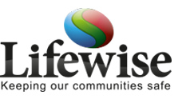

The Lifewise Centre is an interactive learning centre for South Yorkshire communities, developed by South Yorkshire Police and South Yorkshire Fire and Rescue. Featuring a purpose-built set, it is used to educate visitors about safety and citizenship with the ultimate aim of reducing crime and improving quality of life.
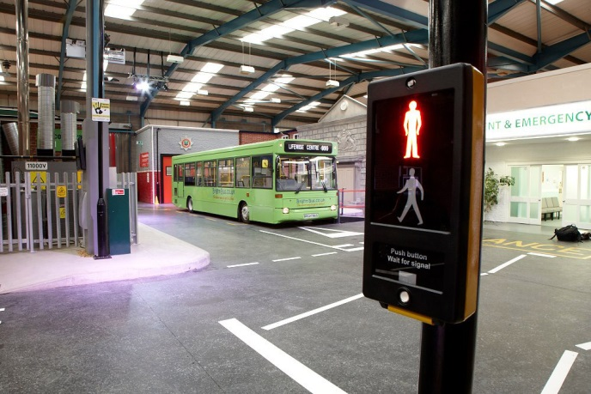
Saturday 13 October 2018
Lifewise
Rotherham, South Yorkshire
9.30am – 4.30pm
Cost to attend: £40 each

Using the fabulous facilities at the Lifewise Centre in Rotherham, WI members are being given a unique opportunity to learn from IAM RoadSmart Observers and Lifewise professionals on various aspects of keeping women safe on the roads. The intensive day will consist of a variety of interactive workshops and driving sessions* covering a range of topics such as:

- Scene management and basic first aid
- Drive for Life: speeding, drink and drugs, safety
- One-to-one driving assessment on motorway, urban and rural driving
- Motorway driving: smart motorways, tailgating, road rage
- Personalised guidance and support from an IAM professional
- Optional one-to-one parking and manoeuvring session (pre-booking necessary).

It is not suitable for members to car share to this event; therefore it is necessary that all attending must arrive and have sole use of their own car throughout the day.

Please note that there is no provision on site for members to bring partners/guests to this event.

A light lunch and refreshments is included in the ticket price.

Spaces are limited and we are expecting this event to sell out quickly. Please complete and return your application form, along with your payment (cheques must be made payable to NFWI) as soon as possible to Helen Neal at the NFWI Unit, Denman, Marcham, Abingdon, Oxon, OX13 6NW. Please contact 01865 391788 ext 279 or
h.neal@nfwi-unit.org.uk with any questions.
* Members must ensure they have a full driving license and insurance and will be required to sign a declaration form to confirm that they have the adequate insurance. Members are not required to take a specific insurance for this day; full comprehensive will suffice.

Please note: ticket price is non-refundable unless the event is cancelled by the NFWI, IAM RoadSmart or the hosting venue.

