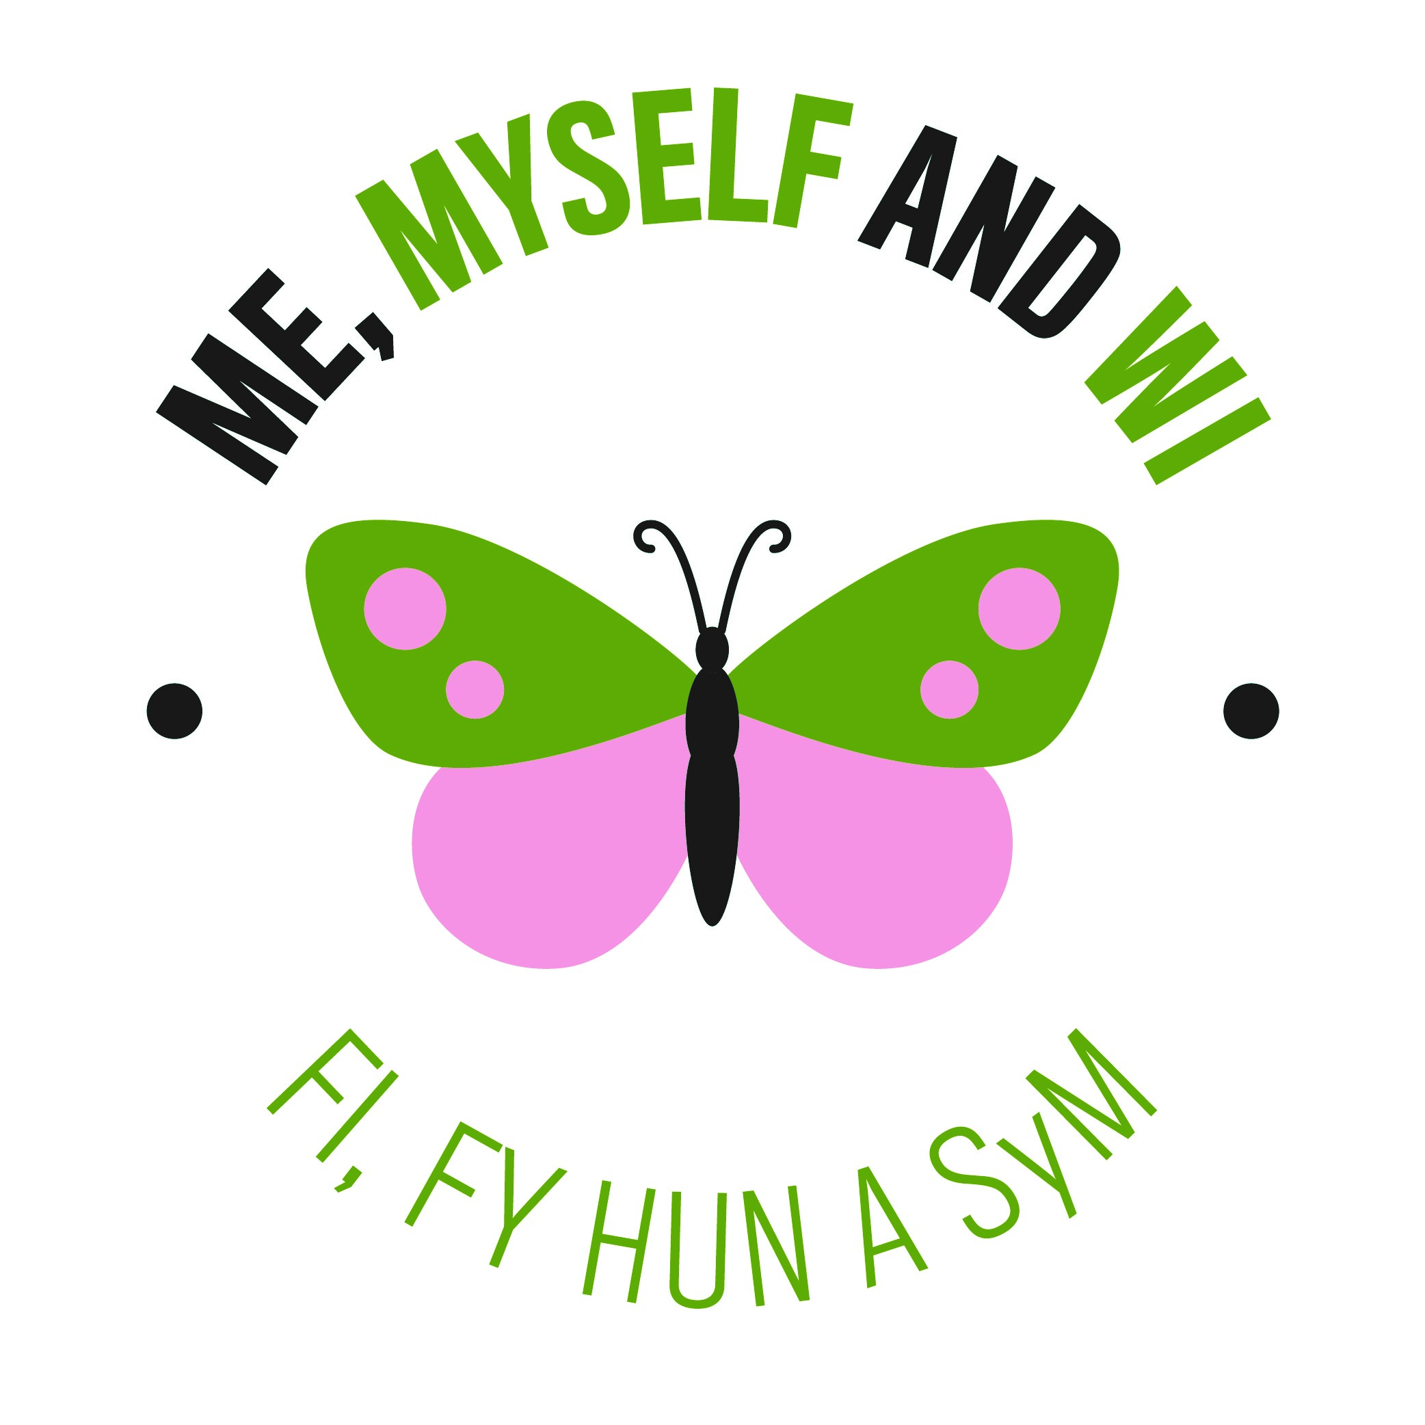
I pledge to…

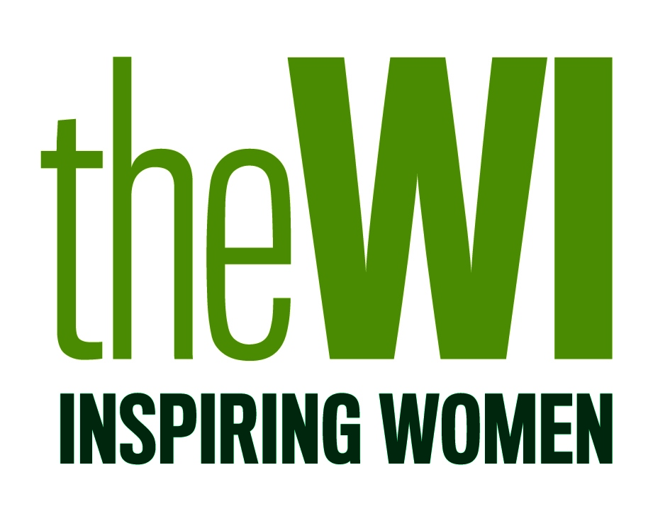

The NFWI is proud to support National Mental Health Awareness Week 2022

