Centenary Panels

You will have seen in the BFWI newsletter in October that as part of the Centenary events the Board of Trustees are asking for contributions of knitted, crochet or fabric panels representing the many interests of WI members.

It is intended that these panels will be used initially in Mortimer during the summer of 2019 so we would like contributions by the end of May 2019. Each panel should measure approximately 12 x 9 inches or 30 x 23 mm and landscape orientation is preferred. As the panels will be displayed out of doors please try to use colourfast materials.

Attached is a list of national WI resolutions going back to the outset and there are a number of resolutions which started in Berkshire. This list is not exhaustive and should not restrict your own imagination

This is a FUN project so no prizes are on offer and no work will be returned. We look forward to receiving as many panels as possible on a wide variety of topics which represent the interests of the WI

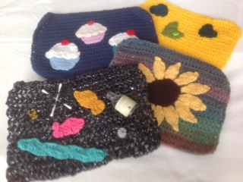

Bunting ideas based on Resolutions plus other ideas
Cakes, Aprons, Midwives - nurses, babies, prams, Libraries, Canning and Bottling
Education, Equal Pay for women, Milk - in school, Farmers, Milk Bottles, Oceans - Plastic Soup, Microbeads, Hygiene - Personal, Food, Sun Flowers, Friendship - Hands Together, Flowers, Loneliness, Agriculture, Green Hearts, Cookery, Save the High Street, Keep Britain Tidy, Dolphins, Crafts - Crochet, Patchwork, Knitting, Art W.I.Logos - Tree, Inspiring Women, Home and Country.

From 1927 to1964 Berkshire has instigated the following resolutions

( I have not traced records for the later years )
June 1927 - Health Policy - B.F.W.I
June 1927 - Food Hygeine/ Safety - B.F.W.I.
May 1929 - International - B.F.W.I.
May 1930 - Environment - B.F.W.I.
May 1935 - Maternal and Child Health - B.F.W.I.
June 1937 - Agriculture and Food - Blewbury & Upton W.I. (Then in Berkshire)
June 1949 - Environment - Thatcham W.I.
June 1953 - Education - B.F.W.I.
June 1960 - Agriculture & Food - 1) Blewbury & Upton W.I. (Then in Berkshire)
2) Cookham W.I.
June 1964 - Health - Whitchurch on Thames W.I.

