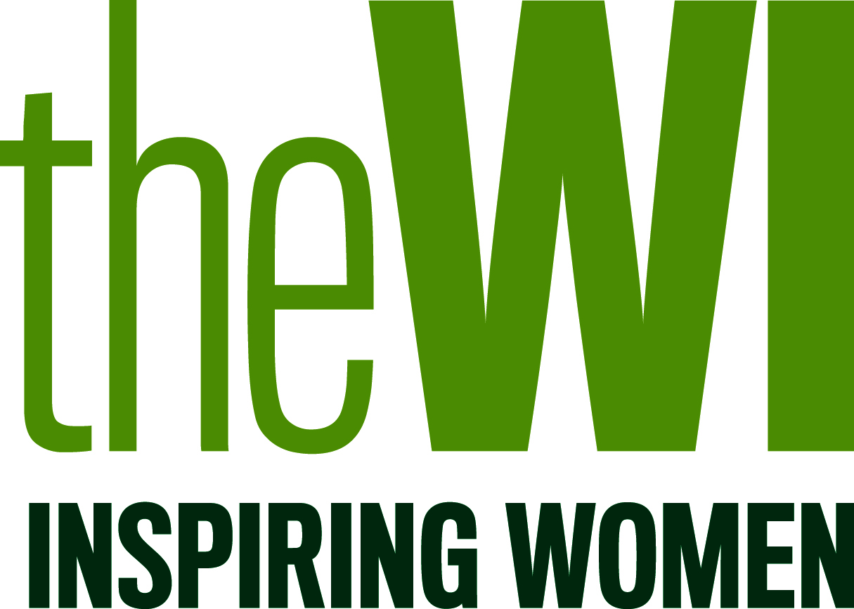

PRESS RELEASE
DATE 2017

YOUR WI/FEDERATION WI members find supermarkets can still do more to help consumers fight food waste

WI members are calling on all supermarkets to work much harder to help consumers reduce their food waste and save money.

Members from YOUR WI/FEDERATION WILL BE TAKING PART/HAVE TAKEN PART in a national WI weekend of action on DATE to raise awareness of the issue and encourage supermarkets to make changes.

Members will be asking supermarkets to sign up to the WI Food Waste Manifesto which sets out a range of actions that supermarkets can take to cut food waste.

The manifesto was developed after WI research found that that supermarket practices are potentially contributing to food waste in the home by leading customers to buy more food than they need, and giving conflicting and confusing on-pack information that leaves customers unsure as to how long a product remains safe to eat in the home setting.

Over 5,000 WI members took part in two surveys looking at supermarket practices across the board, and found that only 45% of WI members surveyed understood that best before dates were an indicator of food quality, and 26% did not understand that use-by dates were a marker of food safety. ‘Once-opened’ instructions which tells consumers how long they have to consume a product once-opened were contradictory and did not make clear whether they were recommendations around food safety, or food quality. This left consumers confused as to how long they have to use a product at home.

WIs up and down the country will be visiting local supermarkets during the weekend of action to meet with store managers and ask them to pledge more action to tackle food waste. The manifesto calls on supermarkets to replace multi-buys with a price reduction, make labelling clear to consumers, stock more wonky fruit and vegetables and commit to publishing their own food waste statistics.

WI members have a long and rich history of working to help everyone prevent food waste by using leftovers, and encouraging people to make the most of local and sustainable food. Members in YOUR WI/FEDERATION have taken action locally by DETAILS ON ANY LOCAL ACTION THAT YOU’VE TAKEN.

YOUR SPOKESPERSON, YOUR WI/FEDERATION, said:

“We want to see supermarkets take more action to help consumers reduce food waste in the home, and to tackle waste at all levels of the food chain.

“WI members are some of the more informed members of society about food and cookery, so the fact that they are still confused about food labelling and ‘once-opened’ information is a damning indication that supermarkets must do more to help all consumers reduce their food waste and ultimately save money.

“ We want to see clear labelling so that consumers understand how to use and store a product once they get it home, as well as extending the amount of time that consumers have to use a product by making ‘once opened’ instructions clear and consistent.

“We all know that time is getting more and more precious as we all get busier, and supermarkets need to make the information shared on their packaging as clear as possible to ensure that consumers are getting the best possible value from their weekly shops, and that food waste is significantly reduced.

“Supermarkets must also take action to tackle food waste through the food chain, so we want to see them stocking more ‘wonky’ fruit and vegetables’ in-store.

“It’s time for supermarkets to start publishing their food waste figures so they can really be held to account, and stop short-changing consumers on shelf-life information to allow them to really get the most out of their food, and turn the tide on increasing food waste.”

-ENDS-

For further information, please contact YOUR NAME, EMAIL ADDRESS AND PHONE NUMBER

Notes to Editors:
- The full report – Wasted Opportunities – is attached and available for download from www.thewi.org.uk
- The full wording of the 2016 resolution is as follows:
“The WI calls on all supermarkets to sign up to a voluntary agreement to avoid food waste, thereby passing surplus food onto charities thus helping to address the issue of increasing food poverty in the UK”
- The WI is the largest voluntary women’s organisation in the UK with approximately 220,000 members in 6,300 WIs. The organisation plays a unique role in enabling women to develop new skills, giving them opportunities to campaign on issues that matter to them and their communities, and provides wide-ranging activities for members to get involved in. For further information please visit http://www.theWI.org.uk

