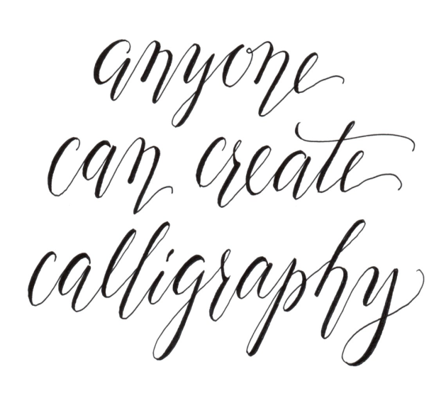
SUFFOLK WEST FEDERATION OF WOMEN’S INSTITUTES
LEISURE SUB COMMITTEE
CALLIGRAPHY WORKSHOP
3 March 2017
AT THE FEDERATION OFFICES AT PARK FARM BUSINESS PARK
10.00 am – 3.00 pm approximately
COST £35.00 PER MEMBER AND £40.00 PER NON MEMBER

Something entirely new this year, a chance to learn how to write beautifully, make your place settings, cards, invitations and much more, even more outstanding. All materials will be provided, and you will have a pen to take home to practice. Our tutor for this event is Christine Robinson, (a professional outside tutor, which is reflected in the cost of this day). Christine will bring all the equipment. The only item you need to bring is a 12” ruler. You will learn a basic script and be able to write a short phrase, make a card or bookmark.
PLEASE REMEMBER TO BRING A PACKED LUNCH WITH YOU. Please note: All bookings represent a commitment to pay. Please contact the office if you are unable to attend _________________________________________________________________________________
Calligraphy Workshop Friday 3rd March 2017. Park Farm
£35 per member and £40 per non-member

WI…………………………………………………Contact Name………………………………….

Address ……………………………………………………………………………………….………

………………………………………………… Tel No……………………………………………….

Please list names and telephone numbers of all attending please

NAME | Telephone number | Member/Non-member

Please Invoice our WI for …………….tickets required @ £35 per member and £40 per non-member

Please return form to:-S.W.F.W.I., Unit 11, Park Farm Business Centre, Fornham St Genevieve, Bury St Edmunds, Suffolk, IP28 6TS or email to office.swfwi@gmail.com and we will invoice your WI

