**Somerset Cider Apple Cake**

**This is the recipe for the competition for the Neil Hanson event 11/10/25**

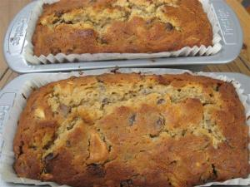

**Makes 2 1lb loaf tins**

**Ingredients**

300g sultanas

142 mls (1/4 pt) medium/sweet cider

240g caster sugar

180g butter

2 large eggs

300g plain flour

360g cooking apples, peeled and chopped small

11/2 level tsp baking powder

1 level tsp mixed spice

**Method**

Place sultanas in a bowl and cover with cider, leave overnight.

Grease and line the loaf tins.

Preheat oven to 180C/170C fan/Gas 4

1 Cream the butter and sugar until light and fluffy, add beaten eggs gradually.

2 Add sifted flour, baking powder and spice. The mixture will be stiff at this stage.

3 Add chopped apple, sultanas and any remaining cider and mix thoroughly.

4 Pour into prepared loaf tins and bake in centre of oven for 45-50 minutes.

If top is browning too quickly, cover lightly with greaseproof paper.

When cooked the cake should spring back and have begun to shrink from the sides of tin.

Leave to cool in the tin.