Move more, feel better with Emma
Saturday 10th September 1.30pm – 3.30pm

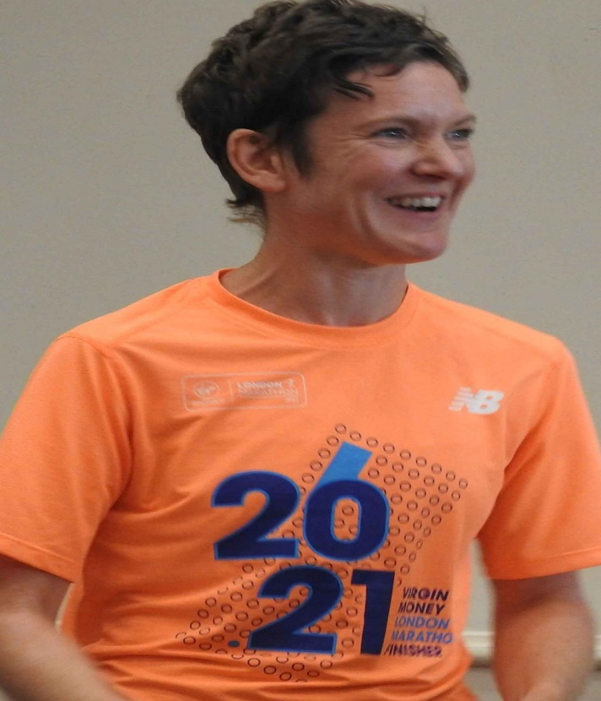

Cost £12

A gentle warm up followed by a workout finishing with a strength and conditioning session. Please wear comfortable clothing – leggings/jogging bottoms and a T-shirt with trainers and either a yoga mat or a large towel to lie on.

Drinks included.

Start Date: 11th July 2022. Closing Date: 19th August 2022
Confirmation will be issued by email on 26th August 2022
If the closing date has passed and you decide you want a place please contact the Office for availability – 01765 606339

From WI
The following members would like to book places on the Fitness Session on 10th September 2022.

Name of member attending | telephone number | email

Either please make ONE cheque payable for the full AMOUNT to NYWFWI and send to North Yorkshire West Federation of WIs, Alma House, Low St Agnesgate, Ripon, HG4 1NG. Please list the event on the reverse of the cheque.
Or alternatively pay by BACS as an on-line payment using: Sort Code: 05-07- 17 Account No: 35739439 and sending a confirmatory email with completed form to nywfwi@btconnect.com

Contact Name and address …………………………………………………………………………………………………………….
Telephone Number: Mobile:
Signed
BOOKINGS are non–refundable.
Confirmation will be emailed out. Please note photographs taken at the event may be used on Social Media.
DISCLAIMER: Participants take part in ALL Federation events and activities at their own risk.
Office Use Only: Cheque Number:

