Fundraising Committee
Contact Anne James 01332 793017
Email anne.james@talk21.com

PLEASE NOTE THIS REPLACES THE HASSOP LUNCH

LUNCH
at
MORLEY HAYES, MORLEY, DERBY
THURSDAY 10TH OCTOBER 2019

GUEST SPEAKER
SIR RICHARD FITZHERBERT BT
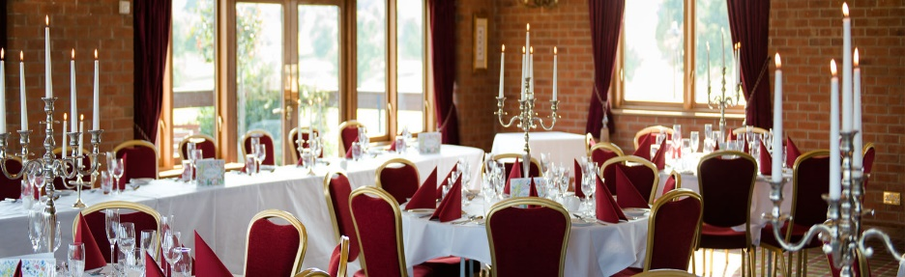
TISSINGTON HALL

Welcome Drink on arrival from 12 noon, Lunch will be served at 1pm

Roast Chicken Breast, potato fondant, thyme, red wine and shallot gravy
OR
Roasted Fillet of Salmon, served with new potatoes, lemongrass and butter sauce
OR
Wild Mushroom, walnut and thyme pithivier, Madeira gravy

Meringue Roulade, white chocolate cream, strawberries, jugs of double cream
OR
Profiteroles with bailey’s cream, warm chocolate sauce
OR
Fresh Fruit Salad

Freshly made coffee or tea with mints

Tickets £37.50

Disabled Access

CLOSING DATE 26th JULY
Application forms with your Secretary
PLEASE STATE NAMES OF THOSE IN YOUR PARTY TOGETHER WITH
THEIR INDIVIDUAL DIETARY NEEDS AND MENU CHOICES.
APPLICATIONS WILL NOT BE ACCEPTED
UNLESS FULL DETAILS AS REQUSTED ARE SUPPLIED

