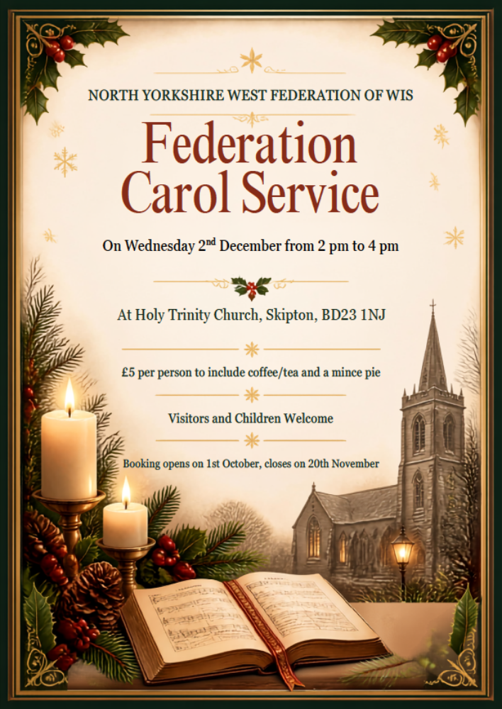

Federation Carol Service on 2nd December 2026 at Holy Trinity Church, Skipton, BD23 1NJ, from 2 pm to 4 pm. Cost £5 per person. Visitors and children welcome.
Booking start date 1st October, closing date 20th November.
Confirmations will be sent out after the closing date.
Places can be booked online at https://forms.gle/RvHVGN5b9yYaSMhL6

From : WI

Name of member/guest | Telephone Number | Email address | Dietary Requirements
Payment Options: CHEQUE payable for the full AMOUNT to NYWFWI and send to North Yorkshire West Federation of WIs, Alma House, Low St Agnesgate, Ripon, HG4 1NG. Please list the event on the reverse of the cheque. ONLINE-BACS Acc Name: NYW Fed of Womens Institute No 1 A/C Charity No 1204475 Sort code: 05-07-17 Account Number 35739439 with Reference Name/WI and sending a confirmatory email with completed form to NYWFWI24@gmail.com.
Please quote Code 26F03CS
Contact Name: |  | Email:
Telephone |  | Signed
CANCELLED BOOKINGS are non-refundable except for exceptional circumstances | If the event is Cancelled cheques will be destroyed - please tick if you require your cheque returned.
Confirmation will be emailed out to the contact’s name. Please note photographs taken at the event may be used on social media.
DISCLAIMER: Participants take part in ALL Federation events and activities at their own risk.

