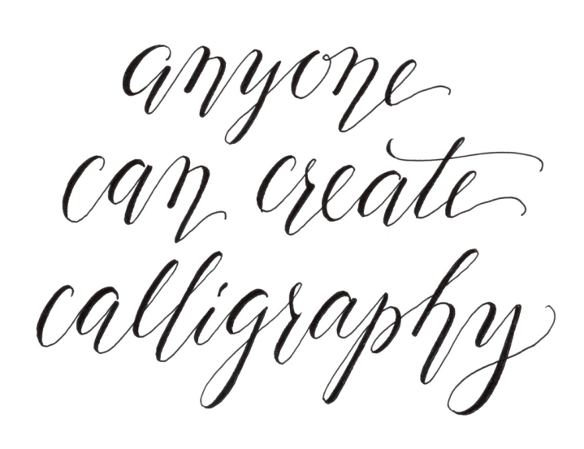
SUFFOLK WEST FEDERATION OF WOMEN’S INSTITUTES
LEISURE SUB COMMITTEE
CALLIGRAPHY WORKSHOP
an additional date by popular demand
Monday 9th October 2017
AT THE FEDERATION OFFICES AT PARK FARM BUSINESS PARK
10.00 am – 3.00 pm approximately
COST £35.00 PER MEMBER AND £40.00 PER NON MEMBER
Our first workshop in March was very popular we are offering members another chance to learn how to write beautifully, make your place settings, cards, invitations and much more, even more outstanding. All materials will be provided, and you will have a pen to take home to practice. Our tutor for this event is Christine Robinson,(a professional outside tutor, which is reflected in the cost of this day). Christine will bring all the equipment. The only item you need to bring is a 12” ruler. You will learn a basic script and be able to write a short phrase, make a card or bookmark. Please let us know on the form below if you are left handed, this is not a problem we just need to know.
PLEASE REMEMBER TO BRING A PACKED LUNCH WITH YOU.
Calligraphy Workshop Friday 3rd March 2017. Park Farm £35 per member and £40 per non-member

WI…………………………………………………Contact Name………………………………….

Address ……………………………………………………………………………………….………

………………………………………………… Tel No……………………………………………….

Please list names and telephone numbers of all attending please

NAME | Telephone number | Member/Non-member | Left or Right Handed?

Please Invoice our WI for …………….tickets required @ £35 per member and £40 per non-member. Please return form to:-S.W.F.W.I., Unit 11, Park Farm Business Centre, Fornham St Genevieve, Bury St Edmunds, Suffolk, IP28 6TS or email to office.swfwi@gmail.com and we will invoice your WI

