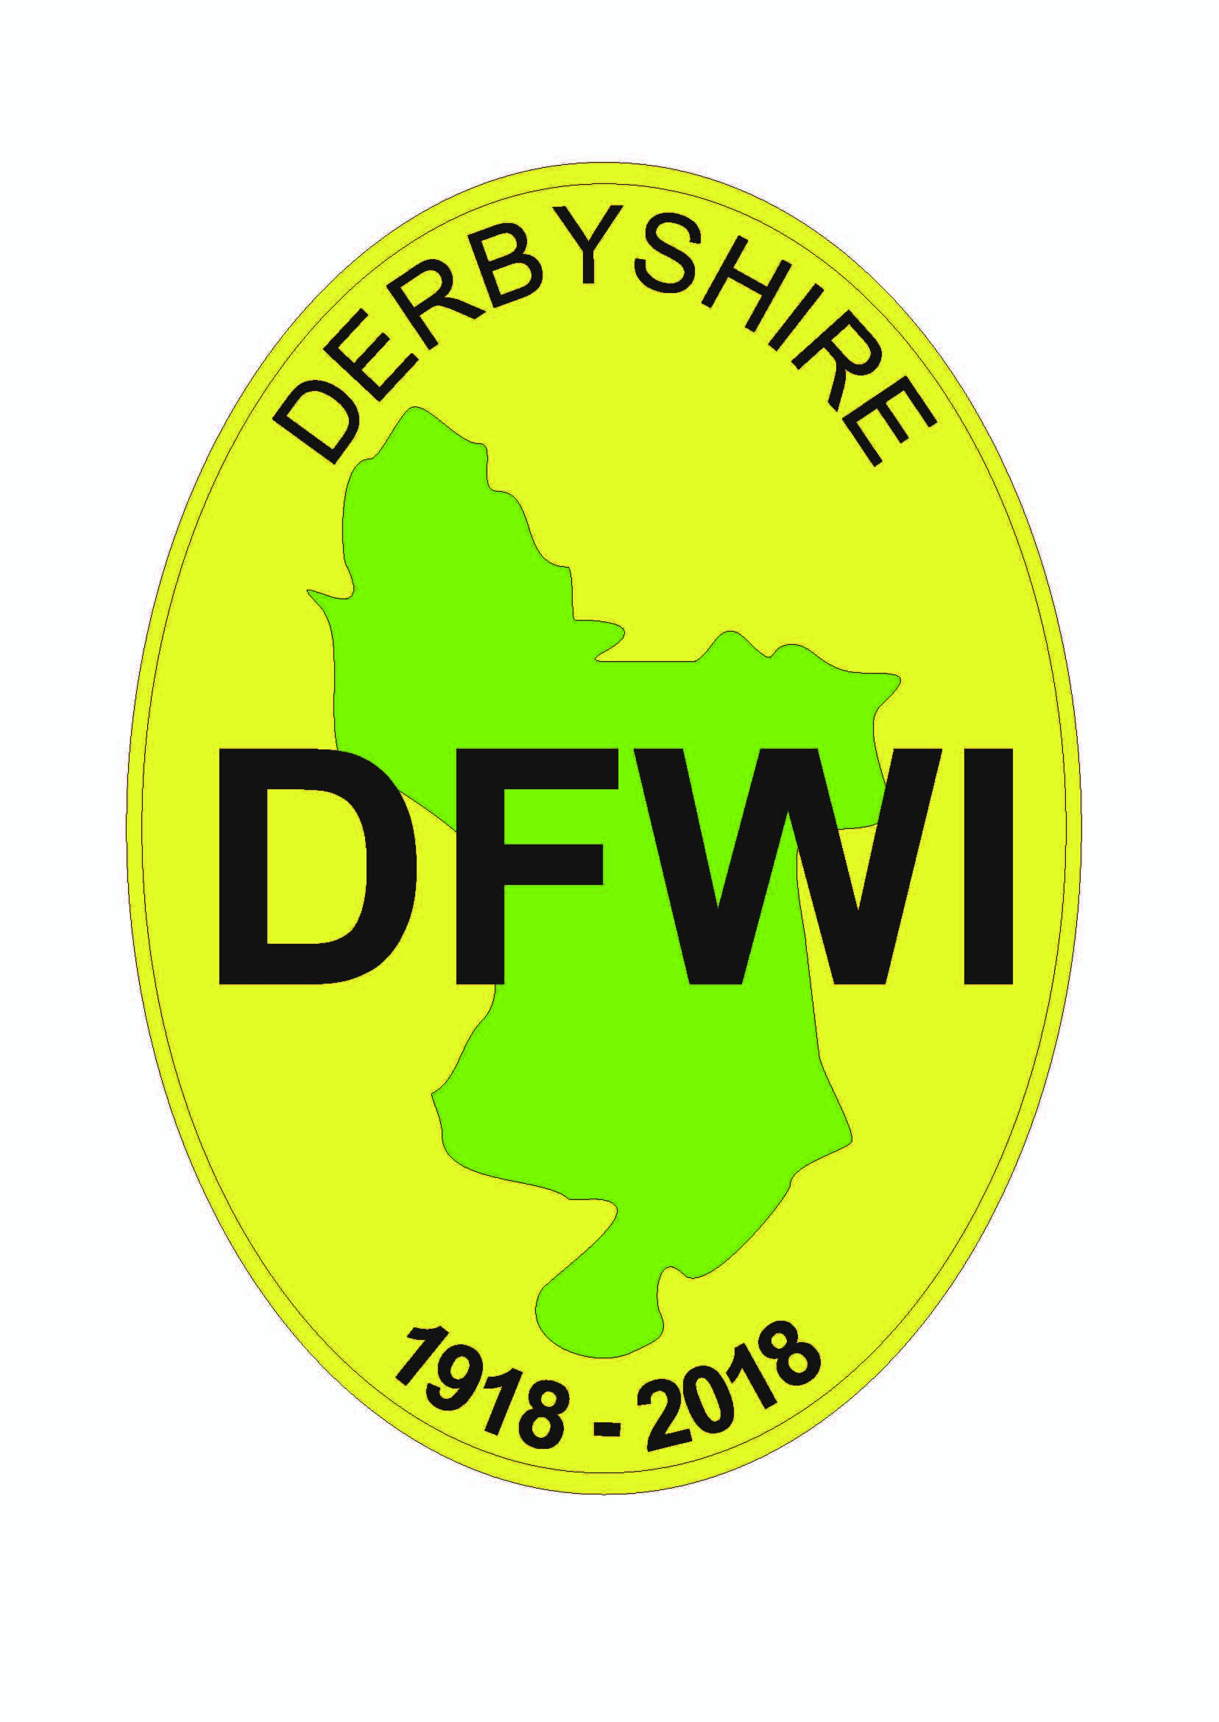 | Derbyshire Federation of Women’s Institutes  GENERAL APPLICATION FORM  To be used for DFWI events and competitions

EVENT: DATE OF EVENT:

VENUE: NAME OF WI:

NAME: ADDRESS:

CONTACT No/MOBILE: EMAIL:

NUMBER OF APPLICATIONS: @ £ each = £

Return to: DFWI, Derbyshire House, Sherwin Street, Derby DE22 1GP, enclosing cheque for total amount, made payable to DFWI, and a STAMPED ADDRESSED ENVELOPE. Wheelchair access is available at DFWI HQ.
No refunds will be given after the closing date of any events.
PLEASE LIST OVERLEAF THE NAMES, ADDRESSES OF APPLICANTS, STATING WHETHER THEY ARE WI MEMBERS AND IF ANYONE HAS SPECIAL DIETARY REQUIREMENTS.

Further supplies of this form are now available for downloading and printing on the DFWI website.

Derbyshire Federation of Women’s Institutes

GENERAL APPLICATION FORM
To be used for DFWI events and competitions

EVENT: DATE OF EVENT:

VENUE: NAME OF WI:

NAME: ADDRESS:

CONTACT No/MOBILE: EMAIL:

NUMBER OF APPLICATIONS: @ £ each = £

Return to: DFWI, Derbyshire House, Sherwin Street, Derby DE22 1GP, enclosing cheque for total amount, made payable to DFWI, and a STAMPED ADDRESSED ENVELOPE. Wheelchair access is available at DFWI HQ.
No refunds will be given after the closing date of any events.
PLEASE LIST OVERLEAF THE NAMES, ADDRESSES OF APPLICANTS, STATING WHETHER THEY ARE WI MEMBERS AND IF ANYONE HAS SPECIAL DIETARY REQUIREMENTS.

Further supplies of this form are now available for downloading and printing on the DFWI website.

