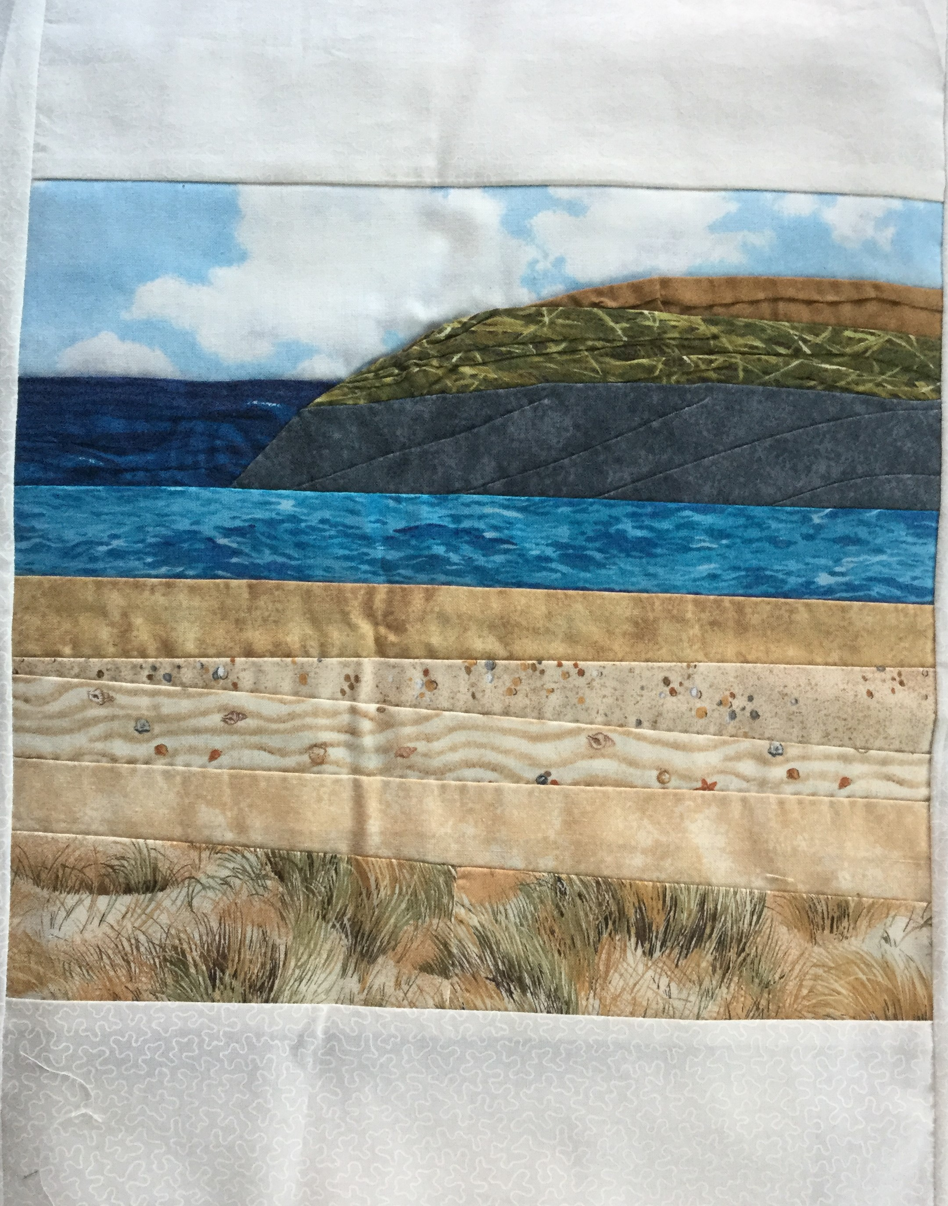

LEISURE COMMITTEE

PATCHWORK SEASCAPE WORKSHOP
MONDAY 27TH FEBRUARY 2017
STURMER VILLAGE HALL; 10am till 3pm
COST: £20 per member (if spaces are available non-members will be invited to the workshop at an additional cost)

Learn to make an attractive seascape scene using a variety of techniques including piecing, applique, quilting, embroidery and embellishment. During the workshop all the stitching will be done by hand. You will be using fabrics printed with sky, sea, grass, flowers etc. to create your scene.
Chris Thompson will be the tutor. She will guide you through each stage and show you how to create your seascape panel. You will then be able to embellish your panel in your own way. Chris will also bring suggestions and ideas for you to try. The finished piece can be framed or turned into a wall hanging or cushion.

Chris will provide all the fabrics, embroidery thread and beads you will need. You will need to bring:-

Medium, sharp sewing needles and pins | Cream or ivory cotton thread
Quilting thread if you wish to quilt your finished piece, | Tacking thread
Sharp scissors and paper scissors | Pencil and sharpener
12 inch ruler | Packed lunch (tea and coffee are provided)
If you have any questions or queries please contact Chris through the office. Please note: All bookings represent a commitment to pay. Please contact the office if you are unable to attend.
Patchwork Seascape Workshop - Monday 27th February 2017 10am – 3pm
WI ………………………………… Contact name ……..…………………………………………
Address……………….………………………………………………………………………………
…………………………………………………………………………………………………………
Telephone……………………………………Email………………………………………………..
Name | Telephone Number
Please return form to:-S.W.F.W.I., Unit 11, Park Farm Business Centre, Fornham St Genevieve, Bury St Edmunds, Suffolk, IP28 6TS or email to office.swfwi@gmail.com and we will invoice your WI

