SPRING COUNCIL MEETING 2024
NORTH YORKSHIRE WEST FEDERATION OF WIS

Wednesday 10th April 2024
At Hampsthwaite Memorial Hall, Hollins Lane, HG3 2EJ
Coffee at 10.00am for a 10.30am start
Ticket prices: Delegates: £27.50 Visitors £32.50
Prices include 2 course lunch, morning coffee on arrival and hot drink after lunch

Morning speaker — Ruth Packwood from Hope at Home—safe homes for survivors of slavery.
Afternoon Speaker –Alan Dedicoat, “The Voice of the Balls” and “Strictly Come Dancing”.
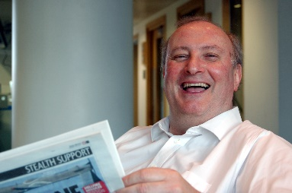

Booking Start Date: 1st January 2024 – Closing Date: 25th March 2024
Confirmation will be issued after the closing date
Please let us know of any dietary requirements you may have
If the closing date has passed, please contact the Office for availability – 01765 606339
Please let us know if you are the Delegate or the Visitor

From: WI
Name and telephone number | Delegate | Email Address

Payment Options
CHEQUE payable for the full AMOUNT to NYWFWI and send to North Yorkshire West Federation of WIs, Alma House, Low St Agnesgate, Ripon, HG4 1NG. Please list the event on the reverse of the cheque.
ONLINE-BACS Acc Name: NYW Fed of Womens Institute No 1 A/C Charity No 513934 Sort code: 05-07-17 Account Number 35739439 with Reference Name/WI and sending a confirmatory email with completed form to NYWFWI24@gmail.com. Please quote code 24F03SC.

Contact Name: Email:
Telephone: Signed:
BOOKINGS are non-refundable. | If the event is Cancelled cheques will be destroyed - please tick if you require your cheque returned.
Confirmation will be emailed out to the contact’s name. Please note photographs taken at the event may be used on social media.

DISCLAIMER: Participants take part in ALL Federation events and activities at their own risk.

