WSFWI ‘NOT THE ANNUAL MEETING’
Join us at Chequer Mead Theatre, East Grinstead, RH19 3LT
Thursday November 10th, 9.30am-1.30pm
Tea and Coffee available (card payment only).
There will be two raffles, one for the flowers and our usual WI one, Gift baskets and sales tables, bring a card and cash along.
Plus two speakers
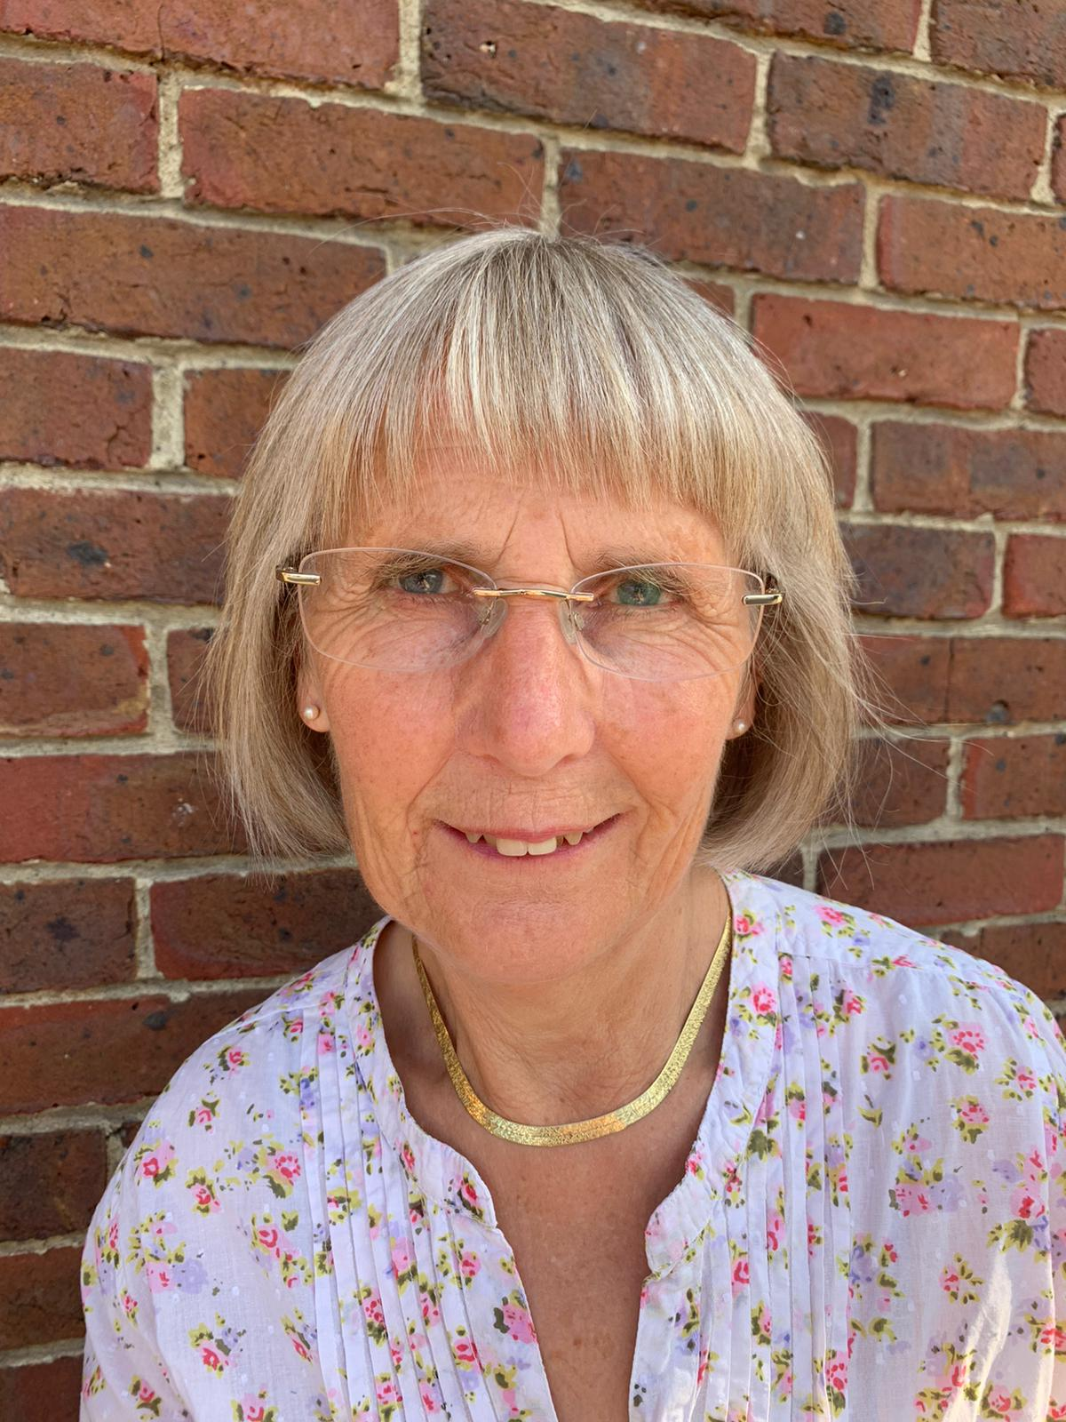
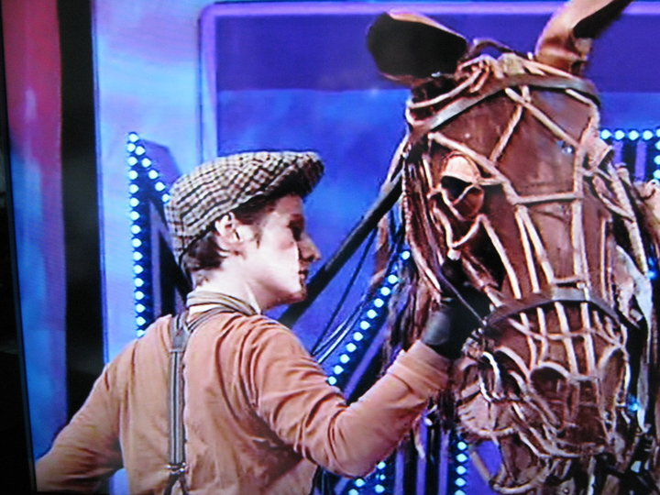
Alison Gillott, NAFAS, Flower Arranger and Ruth Rogers, War Horse Puppeteer

INSIDE WAR HORSE - Ruth Rogers

Ruth Rogers worked as a puppeteer on the National Theatre’s War Horse for four years – first as the only woman operating Joey’s head full time, then as Assistant Puppetry Director. Ruth shares her insider’s experience into what it takes to become a ‘living, breathing’ horse on stage, illustrated with rehearsal photographs and back stage stories from the hit West End show. Whether or not you’ve seen the show –how these life-sized puppets work is a fascinating process which Ruth knows inside out.

Alison Gillott is a Flower Arranging Demonstrator
for the National Association of Flower Arrangement
Societies (NAFAS).
She is a keen competitor at NAFAS Shows, Chelsea Flower Show (Gold Medal and Best in Show 2002), Hampton Court Flower Show and the World Flower Show.
Alison is currently President of the Surrey Area of NAFAS having previously been its Chairman from 2016 until 2019 when she was also a member of NAFAS National Advisory Council.
During lockdown she did 30 online flower demonstrations around the country from her dining room and is pleased to have recommenced her live demonstrating again.

Tickets will be £12 inc. booking fee, available from the

Chequer Mead website and box office

https://tickets.chequermead.org.uk/chequermead/website/ChooseSeats.aspx?WebInstanceId=WI101122

