Emily’s photo diary with Woodley WI
Thursday 13th June 2019
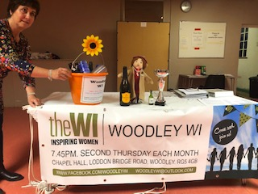

The Woodley WI monthly meeting
What a good start to my week with the Woodley WI!
Juliette and Penny from Woodley Central kindly dropped me off at the Woodley WI meeting and I was very much impressed as the very first thing Woodley WI ladies did was offer me a glass of prosecco in celebration of their success in the Woodley Carnival.
It was a busy meeting with a lively speaker, I liked their trophy cup and was impressed with their new banner!
Friday 14th June 2019
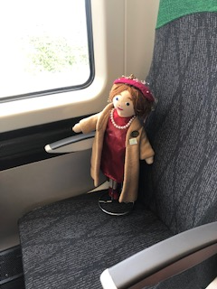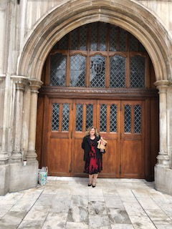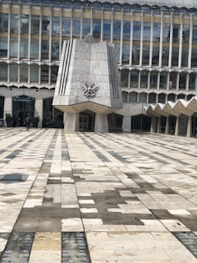
Today I took one of those lovely new electric trains to London and went to the Guildhall to have a look around while Lynn went to an Awards Ceremony there. It’s a beautiful building and I could not resist taking a photo of the lovely crest!
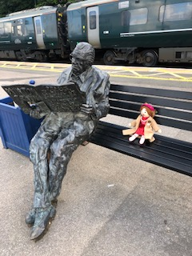 Sitting with Sir Nicholas Winton

On the way home we stopped off in Maidenhead train station and I had a little rest on a bench with this lovely gentleman, he wasn’t very talkative, but he was a very nice man!
Sir Nicholas Winton was 29 when he smuggled 669 boys and girls, destined for concentration camps, out of Czechoslovakia in 1939.
Saturday 15th June 2019
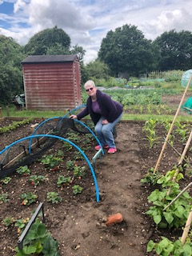 Saturday morning Joyce’s allotment
I really enjoyed my Saturday morning in the fresh air. I learned a lot about working an allotment and it seems like a lot of hard work, so I offered to help with some raking in the bean patch. Joyce had to lift the netting off the strawberry patch for me as I am quite short and couldn’t reach it, but then I thoroughly enjoyed picking the strawberries.
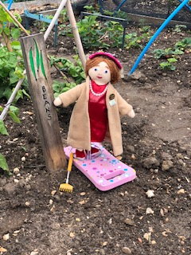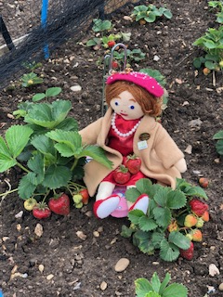
After picking the strawberries I needed to decide what to do with them, so it was off to Woodley Library to check out the cookery books. I just couldn’t resist a bit of hide and seek in the amongst the shelves!
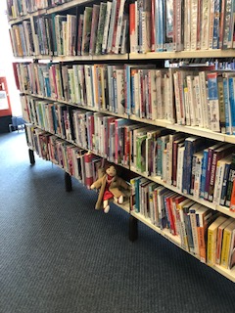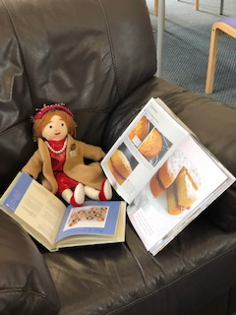

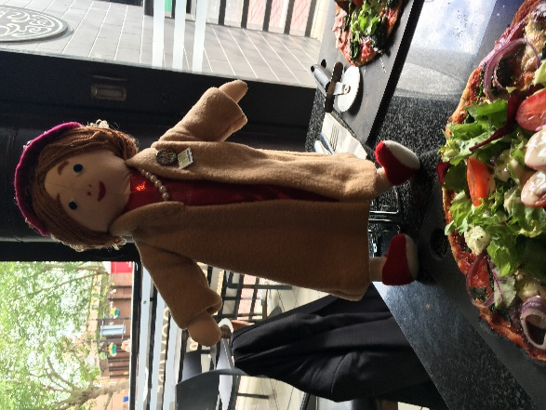 My big Saturday night out

Went for a Pizza one of my favourite foods then off to the Theatre to see Bye Bye Baby! I love Frankie Valli almost as much as I love Elvis!!!
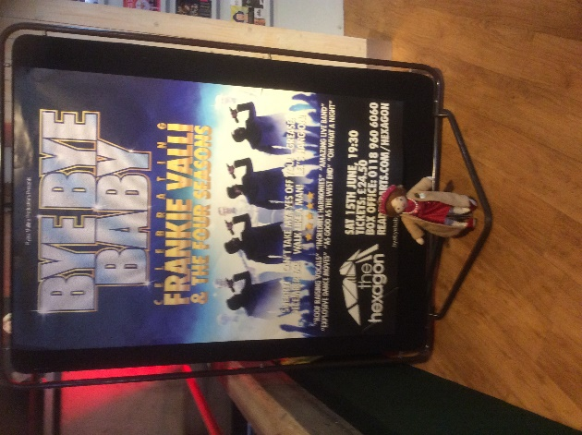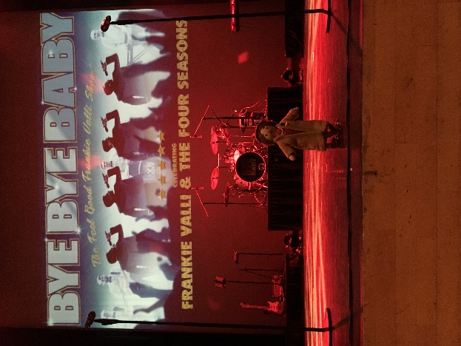
Wow, just look at me sitting on the stage at the Hexagon… Fantastic show and I loved it. What a brilliant end to an amazing day!
Sunday 16th June 2019
Making Jam on a Sunday…. 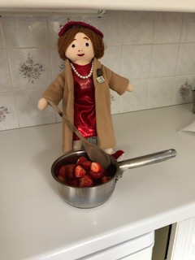
No Sunday lie in for me! I decided to use the strawberries I picked to make Jam.
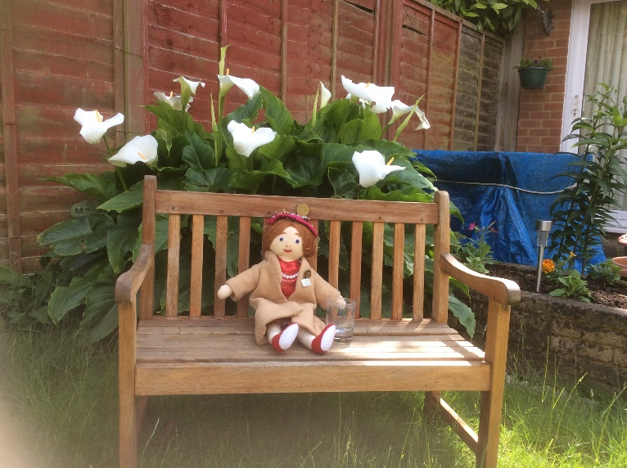
Then a restful day for me after my busy and exciting day yesterday. This bench is just the right size for me and it’s in a lovely quiet spot in the garden.
Monday 17th June 2019

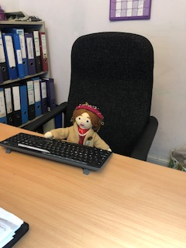 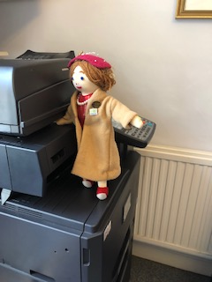 A day in the office 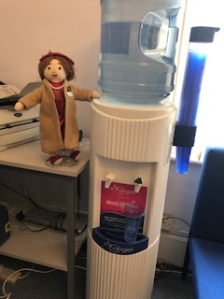 Water cooler gossip?
They say there is no such thing as a free lunch, but I didn’t expect to be put to work! What a day, typing, photocopying, catching up on the office gossip, it never ends! I am pooped.
Tuesday 18th June 2019
A bit of recycling 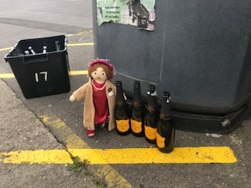 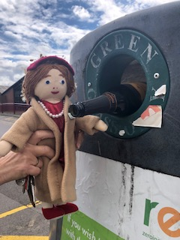
Time to get rid of all those prosecco bottles from the Woodley WI meeting last Thursday so Lynda & I went to the Woodley recycling centre…I can’t believe it’s been less than a week since I arrived, I have been so busy since then it seems such a long time ago!
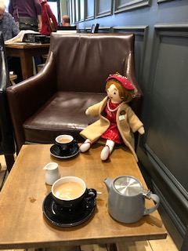 Some leisure time 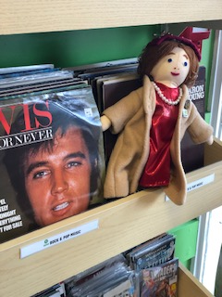

A cup of tea and a bit of a rest in the town café followed by a bit of shopping in the local Oxfam music store! I found my favourite…Elvis….what a treat!

Wednesday 19th June 2019
On my travels again today. This time I am off to Sonning Glebe WI.
Big thanks to the ladies of Woodley WI, it’s been a blast!

