Mini Promo Totem Order Form

Dear Secretary,

Please see the photo below. We are offering you the chance to purchase some promotional totems. We will need your order in DIRECTLY after your March meeting as I have to order from NFWI before month end.

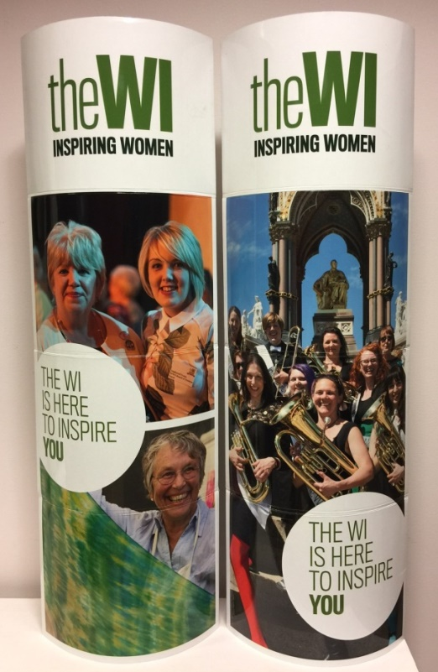
Handy:
Mini totems stand 76cm high and 28cm wide, ideal for table-top use.

Portable:
When folded, each totem measures 28cm x 19cm x 3cm (about the size of a tablet computer) and weighs just 266g.

Attractive:
Double sided design

Useful:
Can be personalized with a WI’s own logo, or chosen caption, stuck over the generic WI logo at the top using glue dots or white tack. NB Each Totem is double sided

This is a one-off opportunity to order. NFWI have not indicated that these Totems will be available to order in the future
---------------------------------------------------------------------------------------------------------
Mini Promo Totem Order Form

WI Name……………………………………………………………………………………………

Contact name and Number…………………………………………………………………

We would like to order 1 Single totem @ £9 each = ……………………………………… £
or ……….. pairs of totems @£14 per pair = ……………………………………… £
Total = ….…………………………………. £

Please invoice my WI for this amount.
Secretary – please send in to Park Farm office.swfwi@gmail.com
Once we have ordered these and received them back from NFWI we will notify you to arrange collection.

