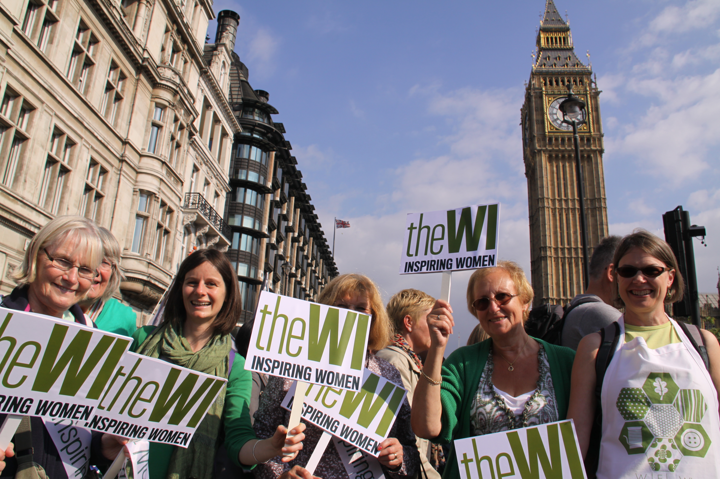

NEW! Photographic Competition
A year in your WI

Inspired by member’s talent and love of photography, the NFWI Science & Leisure Committee invites WIs to submit a collection of photographs depicting a year in their WI.

Running from January – December 2018, WIs are invited to compose a selection of no more than 12 photographs which represent a year in their WI; photographs can be taken monthly or at various events and activities attended or organised by the WI throughout the year.

Schedule
- Photographs submitted can be in black and white, colour or a selection of both.
- Photographs must be no larger than print size 10” x 8”.
- Filters or digital enhancing packages, such as PhotoShop, will be accepted.
- All photographs must be the original work of the WI and taken between 1 January – 31 December 2018.
- Photographs must be taken by a member of the WI; images taken by professional, external sources are not permitted. The final 12 must be chosen and agreed by the WI before submission.
- Consent must be given from all individuals that can be identified in the photographs. If there are children under 18, please ensure that consent is given from either a parent or guardian.
- The chosen 12 photographs can be displayed in any way chosen by the WI i.e. calendar, photo book, scrapbook or simply individual, mounted photographs.
- A supporting paragraph, of no more than 100 words, must accompany each entry.
- A label bearing the name of the WI and federation must be visible on the back of the entry.
- Only one entry per WI.
- Judging will be based on the images, interpretation of theme and overall presentation.

Timescale
- WIs must send their entry to their federation office for initial judging (federations must clearly advertise a closing date for this via their newsletters of WI mailing).
- Federations are invited to send up to three entries for national judging to Helen Neal at the NFWI Unit by Friday 29 March 2019.
- Judging will take place during April 2019 and winner will be notified in writing by end of May 2019.

Prizes
- 1st, 2nd and 3rd prizes will be given in vouchers for photographic equipment.
- The winning entry, runners up plus a selection of chosen entries will be retained by the NFWI for display purposes until December 2019. The NFWI reserves the right to use these images on WI social media channels. Photographs will be acknowledged to the WI.

Please note…
- Individual Entry Forms and Federation Entry Forms must be completed and submitted with the chosen entries, to Helen Neal at the NFWI Unit. Late entries cannot be accepted.
- Federations wanting their photographs to be returned after the competition must enclose a stamped address envelope with their entries.
- This competition is open to all WIs.
- Photographs cannot be submitted electronically (via email or internet sites such as Vimeo).
- Federations are kindly asked to support the competition and publish in their newsletters, a closing date for judging at federation level.
- Please note that entries will be judged in the first instance at federation level and up to three entries from each federation can go forward to the national competition.
- Federations will be charged £10 (incl. VAT) per entry. Please do not send your entry fee with your entries. After the closing date, the NFWI Finance Department will invoice those federations who have entered, accordingly.
- All federation entries will be acknowledged via email to the Federation Secretary.
- No correspondence will be entered into after the competition.



