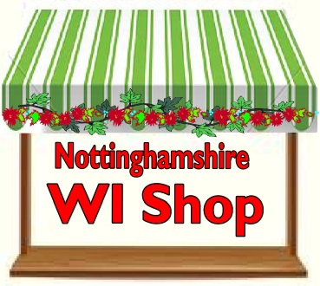 Welcome to the WI Shop
(formerly known as Gifts and Greetings)
The purpose of ‘The WI Shop’ is to raise funds for the Federation. You will see us at Federation and Sub-Committee events throughout the year selling keenly priced giftware and stationery.

You can add a new dimension to your Annual Meeting, monthly meeting or special event with ‘The WI Shop’. Your members can treat themselves to giftware, bakeware and stationery without going to the shops. We buy new stock every Spring and Autumn ensuring there is always something fresh in the shop. All profits from ‘The WI Shop’ will help support the work of Nottinghamshire Federation of WIs.

One or two of our Committee members will set out ‘The WI Shop’ and pack away afterwards, they even bring a large tablecloth. Please note that there will be a charge for travel costs, depending on the distance they have come.

Book a visit from ‘The WI Shop’ by using the slip below, preferrably giving 3 months notice of your event. Or contact County House by email: nottsfedwi@tiscali.co.uk

‘The WI Shop’
BOOKING FORM

WI: _______________________ Location of Meeting: ________________________________________

Contact Name: _________________________________ Tel No _________________________________

Address: _____________________________________________________________________________

Email Address:

Date stall is required: ____________________________ Start Time: _____________________________
Please note that about 45 minutes will be needed before the meeting to set up the Shop.

Return this slip to The WI Shop, Nottinghamshire Federation of WIs, Trent Bridge House, Beastmarket Hill, Newark, Notts, NG24 1BN.

