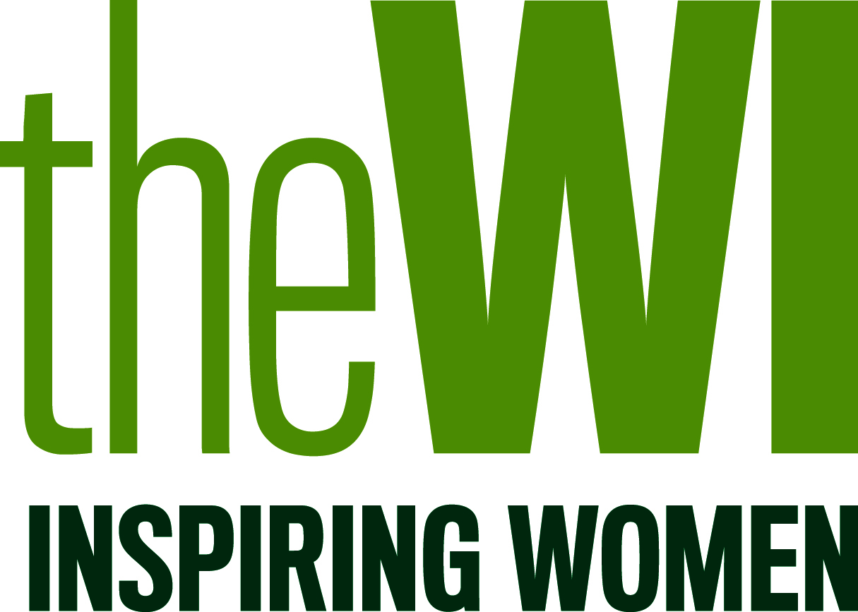

PRESS RELEASE
DATE 2017

[YOUR WI/ FEDERATION] WI members take action on loneliness

To mark World Kindness Day on 13 November 2017, WI members from [YOUR WI/FEDERATION] will be raising/have been raising (delete as appropriate) awareness of the issue of loneliness by [detail the activity that you are planning/have held – e.g holding hands in a show of solidarity with people who are lonely]
MORE INFORMATION ABOUT EVENT IF NECESSARY
In June 2017 WI members voted to back a proposal that seeks to improve the identification of people who are lonely, demonstrating a widespread concern that too often people in the UK are struggling in silence. This campaign will see WI members across England and Wales take action within their WI and federations and initiate conversations with Health and Wellbeing Boards in England, Local Health Boards in Wales and Public Services Boards in Wales.
It is estimated that more than 9 million adults in the UK are lonely ‘always or often’. Yet many people feel unable to tell someone or seek support. Without the necessary support and assistance, research shows that loneliness can have a damaging effect on a person’s mental health, physical health and overall well-being.
[YOUR SPOKESPERSON, YOUR WI/FEDERATION], said:
“The WI has been at the heart of communities for 102 years, and the organisation remains a key place for women to come together to make friends, learn new skills and campaign on the issues that matter to them. WI members in [YOUR WI/FEDERATION] are engaged and active in the local community, and World Kindness Day is the ideal opportunity to reach out to our network to tackle loneliness.”
-ENDS-

For further information, please contact YOUR NAME, EMAIL ADDRESS AND PHONE NUMBER

Notes to Editors:

- The full wording of the 2017 resolution is as follows:
“This meeting calls on every WI and the NFWI to work alongside health and social care providers and their local communities to raise awareness of the causes and impacts of loneliness, thus ensuring better identification of lonely people in order to be able to offer them the appropriate support and assistance”
- The WI is the largest voluntary women's organisation in the UK with more than 212,000 members in 6,600 WIs. The organisation plays a unique role in enabling women to develop new skills, giving them opportunities to campaign on issues that matter to them and their communities, and provides wide-ranging activities for members to get involved in. For further information please visit http://www.theWI.org.uk

Evidence suggests that approximately 75% of people in the UK do not know where to access support and 61% would feel too uncomfortable to tell a family member or friend if they felt lonely.
People who are lonely are more likely to experience difficulties sleeping, feel unhappy, nervous, have low self-esteem and report low life satisfaction. They are also more like to suffer from depression and increased stress levels, experience a rise in blood pressure and develop Alzheimer’s.

