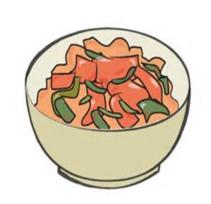
Soup and Natter Lunch
Friday5th May

Hello Ladies

oup ‘n’ Natter ches 2017
Here is a reminder for the Soup n Natter lunch for May 2017. This will be the last one before the summer break.
If you haven’t been before, please come along and see what we have to offer, which is more than just a bowl of soup! We have a choice of two homemade soups and there is usually enough for you to try both, a selection of breads, homemade pates, cheeses & fresh fruit. Also there is a soft drink and tea or coffee to finish with.

Why not bring along a friend or family member as well - ladies only - who doesn’t have to be a W I member.

Cost will be £6.75 for members & £7.25 for non-members

I look forward to seeing you there.

Yvonne
…………………………………………………………………………………………………………………………………………………………………………………..
Please tear off and return

Soup & Natter Lunch – Park Farm Friday 5th May 2017 1.00 pm-2.00 pm
Cost £6.75 for members £7.25 for non-members
WI………………………………………………………..……………………….………………….……
Contact name ……………………………………………………….…………………….…………….
Address…………………………………………………………………..……………………………...
……………………………………………………………………….…………………………………...
Telephone……………………………………Email…………………………………………………..

PLEASE CAN WE HAVE SEPARATE CONTACT DETAILS FOR EACH PERSON IN CASE WE HAVE TO CONTACT YOU FOR ANY REASON

NAME | INDIVIDUAL  CONTACT TEL | INDIVIDUAL  CONTACT EMAIL | SPECIAL DIETARY REQUIREMENTS | MEMBER  YES/NO

Please return with payment to:-S.W.F.W.I., Unit 11, Park Farm Business Centre, Fornham St Genevieve, Bury St Edmunds, Suffolk, IP28 6TS office.swfwi@gmail.com

