Follow the Baton’s journey through Herefordshire
2nd September – 9th September 2014

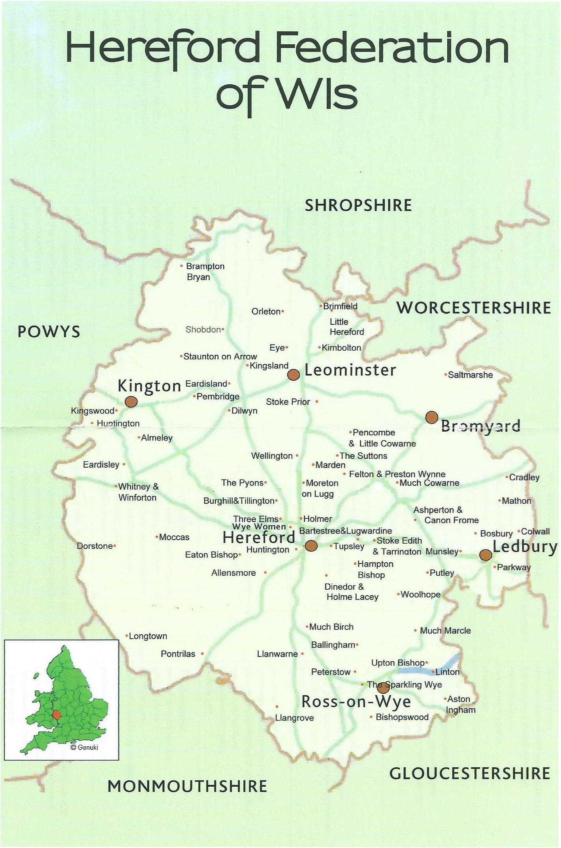
Start
⑧Dorstone & Longtown

⑫Stoke Lacy/Bromyard

④Millennium Green Kingsland

②Toll Bridge, Winforton

Welcome
Allt Yr Ynys Hotel, Walterstone
⑥Ross Rowing Club/Bandstand

Goodbye at
Homme House

⑩Lower Hope Gardens

Finish
⑪Hereford
⑦Hampton Bishop Village Hall
⑬Cradley Village Hall
⑨Queenswood
⑤Still Water Cottage, Orelton
③Staunton-On Arrow Village Hall
①Moccas Village Hall

