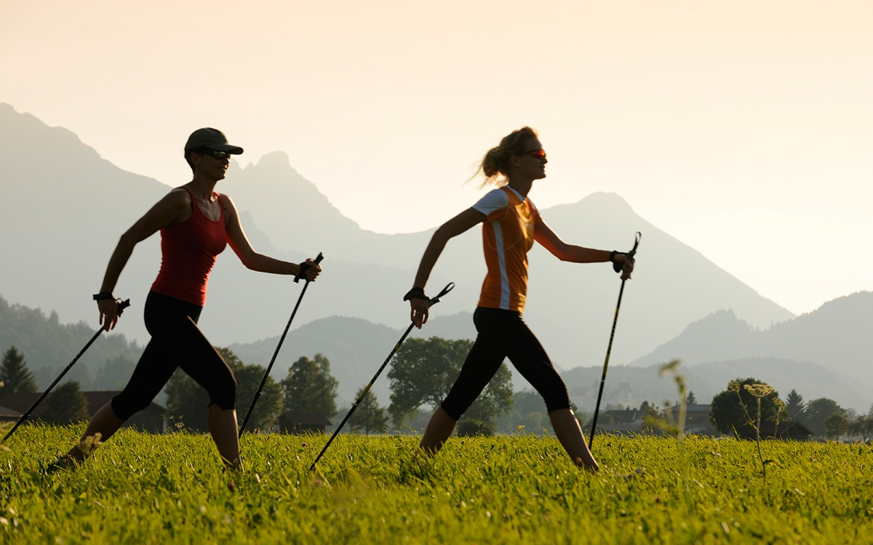

Do You Fancy Something DIFFERENT, Have a trial session of Nordic WALKING?
Tutor is Mike Stead from Positively Nordic
Venue- Crimple Valley old Golf Course, Harrogate
Date Tuesday 5th April 2022, there are 6 places in two sessions
200-3:00 and 6:00-7:00 Cost £7.50 per participant
Booking opens Tuesday February 1st closes Tuesday March 23rd
Confirmation will be by email, contact the office for availability after closing date

From ------------------------------------------------------------------- WI
We would like ------------------- tickets please give names of participants on the reverse of the form
Contact details -name & email address-----------------------------------------
Telephone number------------------------- Mobile--------------------------
Payment to be made by cheque payable for the full AMOUNT to NYWFWI and send to North Yorkshire West Federation of WIs, Alma House, Low St Agnesgate, Ripon, HG4 1NG. Please list the event on the reverse of the cheque.
Confirmation will be emailed out to the contact’s name. Tickets are non-refundable
Please note photographs taken at the event may be put on social media
DISCLAIMER: Participants take part in ALL Federation events and activities at their own risk.

Office Use Only: Cheque Number:

