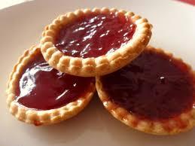

Wednesday 11th April 2018 7:30 – 9:30 (Doors open at 7:15)
St John’s Church Hall Long Eaton NG10 4 JP; Ticket price of £7:50

Come and hear tips and insights into how to improve your baking skills and not lose any of the 20 points you start off with at a WI Show!
Maureen Anderson will be judging Jam Tarts and Lemon Drizzle Cakes and presenting a running commentary of how she ends up with her final marks.
There will be a break midway with refreshments including Canapes and Nibbles
Queries to Fay Rumley Tel 07789 394931
Application forms should be sent with SAE to Derbyshire House, Sherwin Street, Derby DE22 1GP. If the event is oversubscribed there will be a ballot after the closing date.
Closing Date: 16th March 2018

