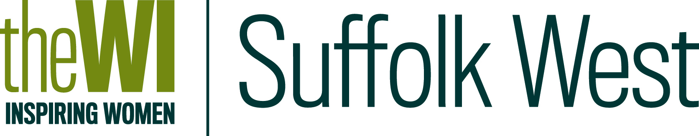
SAVE THIS DATE!!
The 2017 RESOLUTION CONFERENCE
WILL BE HELD ON
WEDNESDAY 26th APRIL 2017 at 7pm
On Wednesday 26th April, at Moreton Hall Community Centre, Bury St Edmunds, IP32 7EW, you will have the chance to hear from expert speakers talking about the 2017 resolutions to go forward to the NFWI Annual Meeting in Liverpool in June. The plan for the evening is to begin with coffee and tea from 7pm ready for a prompt start at 7.30pm. There will be presentations from speakers for and against the resolutions (although this is not always possible to achieve) followed by a debate on each subject. There will also be guidance for delegates. This should make for a very varied and interesting evening.
A booking form and further information detailing which resolution or resolutions have been chosen will be in your March mailing.

The cost will be £7 per WI, so don't just come on your own
SAVE THIS DATE!!
The 2017 RESOLUTION CONFERENCE
WILL BE HELD ON
WEDNESDAY 26th APRIL 2017 at 7pm
On Wednesday 26th April, at Moreton Hall Community Centre, Bury St Edmunds, IP32 7EW, you will have the chance to hear from expert speakers talking about the 2017 resolutions to go forward to the NFWI Annual Meeting in Liverpool in June. The plan for the evening is to begin with coffee and tea from 7pm ready for a prompt start at 7.30pm. There will be presentations from speakers for and against the resolutions (although this is not always possible to achieve) followed by a debate on each subject. There will also be guidance for delegates. This should make for a very varied and interesting evening.
A booking form and further information detailing which resolution or resolutions have been chosen will be in your March mailing.

The cost will be £7 per WI, so don't just come on your own

