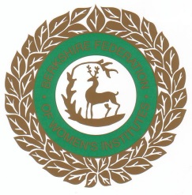****

Dear Member,

A very warm welcome to the WI new member pack. You are now part of the largest women’s organisation in England and Wales with more than 215,000 members in over 7,000 WIs. Berkshire Federation has over 2,950 members.

Your membership entitles you to 11 regular WI meetings and 8 copies of WI Life per year. The WI membership booklet, which you will be given each year, contains your membership card and lots of special offers and vouchers. The WI Moodle (modular Object Orientated Dynamic Learning Environment) is an invaluable on-line training and resource centre – contact WI House at Mortimer for your access code. Berkshire Federation has our own newsletter (10 issues per annum) which you will be given at your monthly meeting. This will keep you in touch with the many and varied events organised by Berkshire Federation’s sub-committees.

Further, enclosed in this pack you will have information about all aspects of the WI, including our history, Denman, WI’s own residential college, the National Federation and Berkshire Federation and ACWW – Associated Countrywomen of the World.

We are always here for you so the Berkshire Federation Board of Trustees and our WI House office staff join me in welcoming you as a member of this great organisation and wish you many happy years full of fun and friendship.

With my sincere best wishes,

**Marlene Voke**

**Federation Chairman**



**A Modern Voice for Women**

The ideals of the Women’s Institute of truth, justice, tolerance and friendship are as strong and important now in the 21st century as they were at the birth of the WI in 1915. The WI is the largest voluntary women’s organisation in the UK. It exists to educate women to enable them to provide an effective role in the community, to expand their horizons and to develop and pass on important skills.

WI has an unrivalled reputation as a voice of reason, integrity and intelligence on issues that matter to women and their communities. Support for British agriculture, the importation of foodstuffs and care of the environment, are just some of the issues on the WI’s campaigning agenda. Any WI member can put forward a resolution to National, and if it gets through the elimination process, it could be voted on at the National Annual Meeting for further action. The WI has lobbying power that can influence governments.

The WI is an educational, social, non-party political and non-sectarian organisation. Through its close community ties and wide-ranging activities, the WI plays a unique role in enabling women to turn their interests into achievements and their concerns into campaigns.



**The National Federation of Women’s Institutes**

The WI is a national organization and has its own headquarters in London with professional staff, as well as offices in Wales and at Denman. These offices manage and co-ordinate WI affairs and offer a wide range of services to members. The whole is overseen and run by the National Board of Trustees consisting of volunteer members elected from all over the country.

If you are busy with work, family and social life but care about the community, important issues and want to learn new skills – you can join as an NFWI Associate, which includes a copy of our excellent magazine, WI Life, delivered to your door.

**WI Life**  This is the WI’s own magazine, published 8 times a year by the National Federation. It contains articles and reports about aspects of WI from around the regions. It is a good read, and as a new member helps to keep you up to date with what is happening in the organisation. Once registered on the Membership Communication System (MCS) you will automatically receive your copies.

For further information about the NFWI, please contact:

NFWI

104 New King’s Road, London SW6 4LY

Tel: 0207 371 9300 Email: [hq@nfwi.org.uk](mailto:hq@nfwi.org.uk) Website: www.thewi.org.uk

[www.facebook.com/thewi](http://www.facebook.com/thewi) or Twitter @womensinstitute

NFWI also have a Unit at Denman,

Marcham, Abingdon, Oxon OX13 6NW

Tel: 01865 391991 Email: [denman@nfwi-unit.org.uk](mailto:denman@nfwi-unit.org.uk)

Website: [www.thewi.org.uk](http://www.thewi.org.uk)



**History**

Originating in Canada, the WI was founded by Adelaide Hoodless, a farmer’s daughter who had lost her fourth child through ignorance of basic hygiene. The first meeting was attended by 101 women at Stoney Creek, Ontario and urged that lectures and demonstrations in domestic science and home-crafts be made available to rural women.

1897 First WI formed in Canada

1915 First WI in Britain formed at Llanfair PG, Wales

1917 First AGM, chaired by Lady Denman who held the position as National Chairman for 29 years.

First WI in Berkshire formed in Burghfield

First County Federation formed in Sussex

1919 Berkshire Federation of WIs formed

First issue of Home & Country published

First WI Market opened

1933 Associated Country Women of the World (ACWW) founded

1948 Denman College opened. First Ministry of Education grant

1989 BFWI moves from Watlington House, Reading to WI House, Mortimer

1990 NFWI becomes a charitable company limited by guarantee

1992 Denman College opened to non-members

Financial division of WI Markets, a business, and NFWI a charity

2007 WI Life. Membership Communication System (MCS)

2008 MOODLE. Online training and resource centre

2015 WI Centenary



**WI Jargon Buster!**

**ACWW**

Associated Country Women of the World

**Annual Meetings**

Held by each WI to elect President and committee, review past year’s work and finances.

**ACM**

Annual Council Meeting of the Federation, held in the Spring. Each WI sends a voting delegate.

**BFWI**

Berkshire Federation of Women’s Institutes

**IFE**

Independent Financial Examiner

**MCS**

Membership Communication System

**MOODLE**

WI’s own online training and resource centre.

**NFWI**

National Federation of Women’s Institutes.

**Resolutions**

Public affairs issues discussed annually by all WIs.

**WI**

Women’s Institute

**WIA – WI Adviser**

A member trained to form new WIs and help existing ones as required.

theWI logoGrey

DENMAN

Did you know that the WI has its own residential college in Marcham, near Abingdon in Oxfordshire? The elegant Georgian house set in seventeen acres of peaceful parkland and gardens has a teaching centre and comfortable accommodation. There is something about Denman that captures the heart of everyone who goes there, enticing them to return.

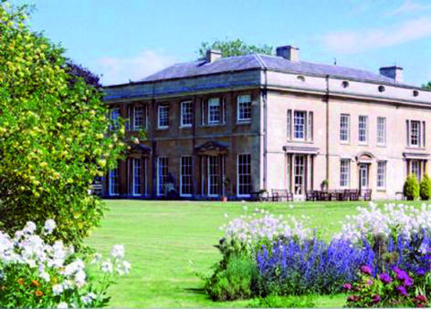

Courses range from Antiques through Art & Crafts appreciation, Dance, Health & Fitness, Gardening, the Countryside, Personal Development, Science and Technology to Sports and Leisure. The College offers more than 500 courses annually and can accommodate over 80 students. A course can cover a single day, or up to five days.

WIs are strongly encouraged to provide a bursary for their members to be drawn annually where funds allow. The current brochures are issued three times a year, and can also be accessed via the website. Further copies can be obtained from Denman direct.

Denman,

Marcham, Abingdon,

Oxfordshire OX13 6NW

Tel: 01865 391991 Email: **info@**[**denman.org.uk**](http://denmon.orq.uk)

[**www.denman.org.uk**](http://www.denman.org.uk)

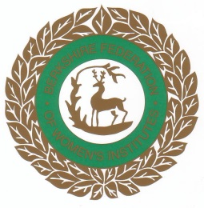

**The Berkshire Federation of Women’s Institutes**

The BFWI has its headquarters at Mortimer and is run by three members of Staff.

An elected Board of Trustees undertakes the overall responsibility for the office and all sub-committee work. The sub-committees organise a range of events and activities for Berkshire members.

BFWI publishes a monthly newsletter **Berkshire News** to keep its members informed of all the events and activities in the county. This can be ordered through your WI.

The BFWI Year Book is an annual publication issued to every WI and contains information about speakers, Groups, sub committees, outside organisations and lots more. Your Secretary will have a copy – ASK TO SEE IT – or better still buy your own!

All members are welcome to visit WI House, please telephone first.

For further information on any of the above, please contact:

BFWI Office Hours:

WI House, The Street 10.00am to 3.00pm

Mortimer Common (Tuesday to Thursday)

Reading 10.00am to 1.00pm

Berkshire RG7 3RD Friday

Tel: 0118 933 3448 CLOSED MONDAY

Email: [bfwi@clara.net](mailto:bfwi@clara.net)

Website: [www.thewi.org.uk/berkshire](http://www.thewi.org.uk/berkshire)

[www.Facebook/berkshirefederationofwis](http://www.Facebook/berkshirefederationofwis)

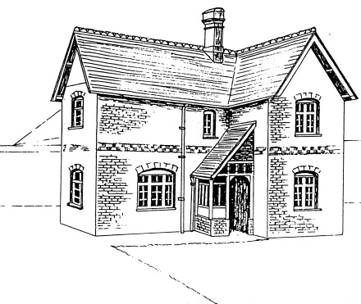

**History of WI House Mortimer**

1855 A Parcel of land was set aside by Edward Richard Benyon of Englefield House for the provision of a Church or Chapel, a Church Elementary School and a Clergy House.

1882 The original church, that is, the present south aisle and vestry, was completed and dedicated to St John the Evangelist.

1889 St John’s Church of England School together with a School House (now WI House) for the use of a teacher was opened.

1895 A conveyance by Richard Benyon of Englefield to the Right Reverend Father in God, William, Lord Bishop of Oxford conveyed the land and buildings as an Ecclesiastical Charity for the Church of England. There were three schedules:

1. The Church
2. The School and School House
3. The Clergy House to the rear of the school known as St. John’s March.

1896 The enlargement of St John’s Church completed and dedicated.

1966 The land and building referred to in the third schedule, St John’s March, was conveyed from the trust to the Church Commissioners who sold it on as a private dwelling.

1989 The School House was conveyed to the Berkshire Federation of Women’s Institutes by an authority of the Charity Commission dated 13.04.1989. This is 100 years since the original opening of the school and house.

----------------------

Since the house opened in 1889 it has been occupied by a succession of teachers and later by curates. The last occupant was Miss Elizabeth Shrimpton, a parish lay worker, who retired and left the house on 25.05.1983. From that date until the sale of the house to the Berkshire Federation of Women’s Institutes it was used as a crèche and to store Sunday School equipment. The only other occupants were jackdaws who regularly fell down the chimneys!

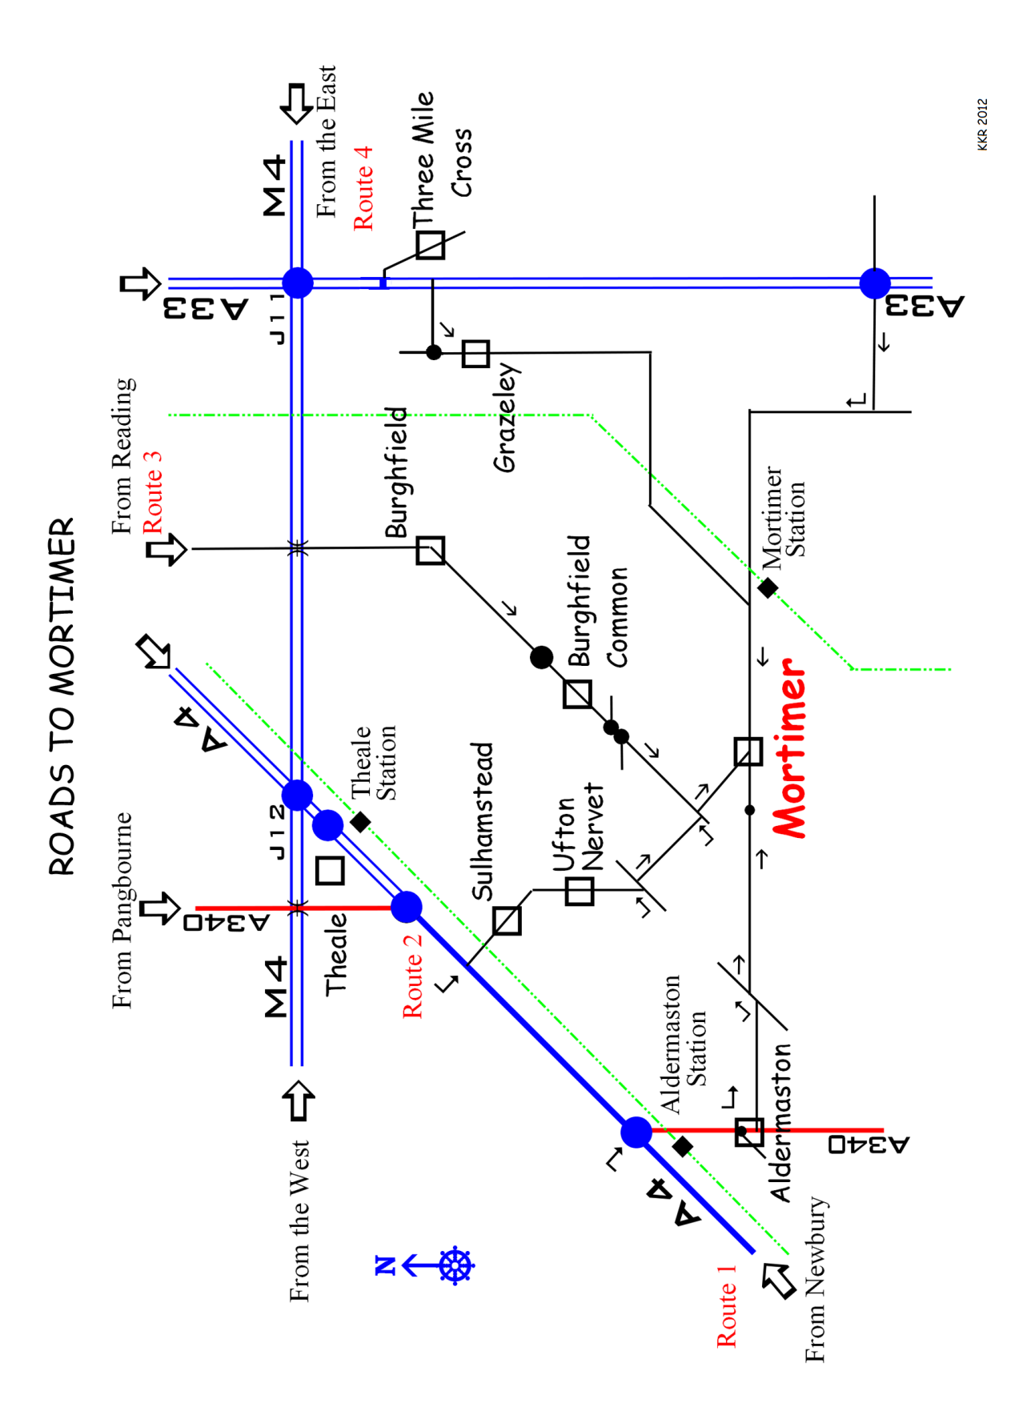

# Recommended routes to Mortimer – refer to Map

# Please note Mortimer West End and Stratfield Mortimer are hamlets to the West and East of Mortimer

# Route 1 – From Newbury and the A4 West

Travel on the A4 towards Reading

Turn Left at the roundabout signposted A340 Aldermaston

Entering Aldermaston continue forward at mini-roundabout through village. At top of main street bear Left onto Church Road signposted Padworth, Silchester, Mortimer. Continue on Red Lane to Tjunction and then turn Left and next Right. Continue on to Mortimer.

# Route 2 – From Pangbourne/M4 Junction 12/Theale

Travel on the A4 towards Newbury

Turn Left at the ‘Spring Inn’ signposted – Sulhamstead, Police Training College. Continue on this road onto Sulhampstead Hill, Church Lane and through Ufton Nervet. Turn Left at Tjunction and then next on the Right into Victoria Road. Turn Left and then Right at the Tjunction and forward to Mortimer.

# Route 3 – From Reading A4

Travel out of Reading on A4 towards the M4 Junction 12

Turn Left at the traffic lights signposted Burghfield.

Remain on this road through Burghfield, Burghfield Common and continue forward at two mini-roundabouts signposted Mortimer.

Continue on this road into Mortimer.

# Route 4 – From M4 Junction 11/ Reading A33

Travel from the M4 Junction 11 on the A33 towards Basingstoke.

After the first set of traffic lights filter right at next traffic light junction (approximately 250 metres) onto Mereoak Lane, then turning left to Burghfield and Mortimer. Continue on this road through Grazeley and onto Mortimer.

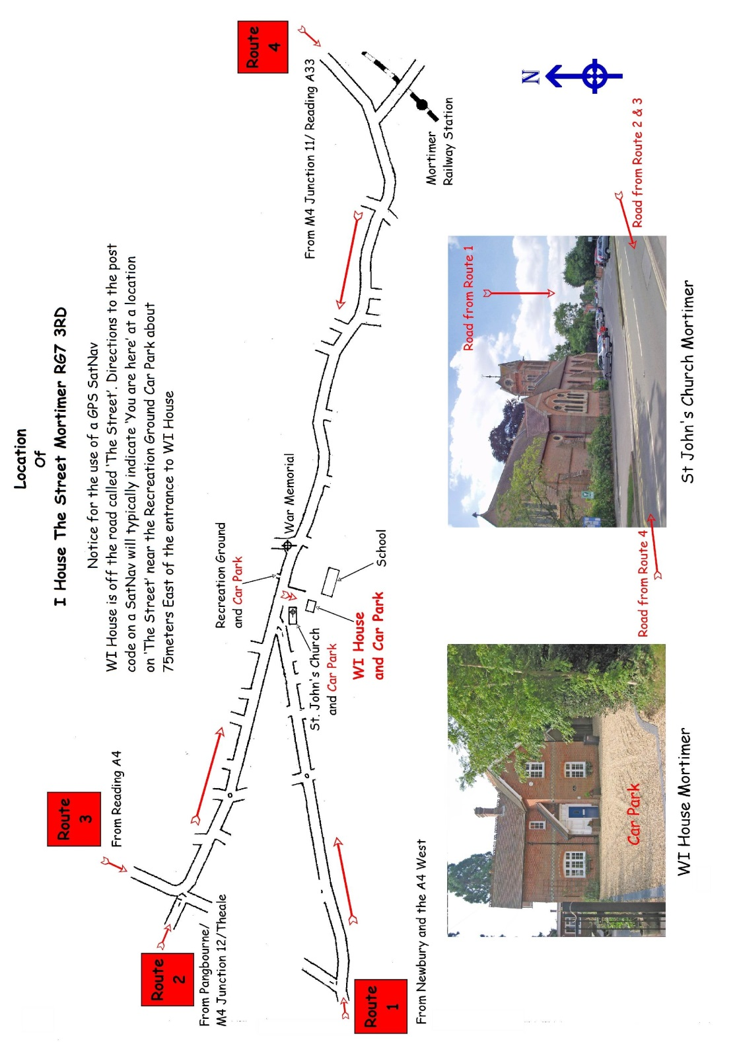

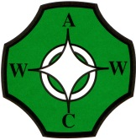

**Associated Country Women of the World**

All WI members are automatically part of the women’s international organisation ACWW. This is the largest international organisation of rural women and links nine million members through 365 Member Societies in over 70 countries. ACWW is a non-sectarian and non-political organisation with charitable status. ACWW receives no government funding and is entirely dependent for income from the annual dues paid by its members (individual members and societies) as well as donations through the ‘Pennies for Friendship’ scheme which is supported by many WIs throughout the UK.

Its members pledge to improve living conditions in a practical way and support basic education and local development projects to fight hunger and disease. It also gives rural women a voice at international level through its links to UN agencies.

ACWW promotes training for women in developing countries in nutrition, agriculture, literacy, income-generating schemes, environment, housing and water projects in rural communities. They have their own quarterly magazine, The Countrywoman, which updates members on current projects and activities.

For further details please contact the Berkshire ACWW Representative (see BFWI Year Book) or see below for contact details.

**“Working with Women Worldwide”**

ACWW

Mary Sumner House

24 Tufton Street

London SW1P 3RB

Tel: 020 7799 3875

Email: [info@acww.org.uk](mailto:info@acww.org.uk)

Website: [www.acww.org.uk](http://www.acww.org.uk)