Centenary Wall Hanging
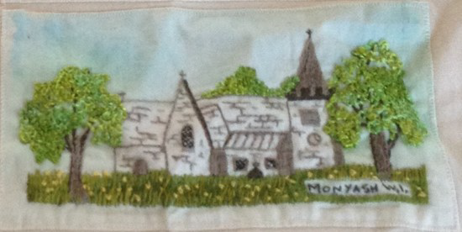
To commemorate the century of the Derbyshire Federation of WIs in 2018 every WI in the federation is being offered the opportunity to design and make a “fabric brick” depicting their WI.
The brick will be approx. 22.5 cm x 10cm and can be in any medium. The material will be provided by the federation and the project will commence in January 2017. Bricks will need to completed and returned to the federation by the end of January 2018. The bricks will then be assembled to create a wall hanging depicting all WIs in the federation in the centenary year.
This wall hanging will complement the two previous wall hangings which were completed in the 1980s and the year 2000. The wall hangings generate a great deal of interest when displayed at council and federation meetings and at the County and Bakewell Shows and are a unique record of WIs in the federation.
To take part in this project please complete an application form and return to Derbyshire House, Sherwin Street, Derby DE22 1GP enclosing an A4 SAE.
All WIs should receive an application form in the October mailing, forms can also be obtained from the DFWI website or by contacting:
Maureen Anderson Tel 01332 863901
email maureen.anderson1953@yahoo.co.uk
We look forward to receiving your applications.
Closing date for applications is Monday 30th January 2017

